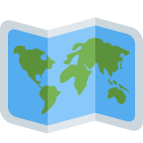

Untitled Mapping Project

Peter Warrington’s NEA project

# Analysis

## The problem

For my NEA, I have decided to create a self-hosted mapping solution, accessible from web clients via an API. This is as opposed to commonly used proprietary cloud services that are hosted by third parties, such as Google Maps, which cannot be hosted on-site, and which do not allow organisations and individuals the high level of control a self-hosted system provides.

This may be useful for individuals that have access to such services blocked or censored due to Government influence, where a decentralised self-hosted service allows people to avoid this. For example, mapping services offered in China face strict legislation that mandate these to meet Government conditions, for example to reflect their government’s own disputed position on territorial boundaries.[1]

It may also be useful for organisations that want to manage and share their own confidential map data securely with authorised parties.

This service should be fully accessible from a variety of platforms, including desktops, smartphones and tablets in order to provide a mapping service for users when they need them, much like Google Maps. It was for this reason that I decided to create a web application for this service that communicates with the server in order to meet these requirements.

## Problem research

In order to begin to understand how a solution to this problem could be approached, I broke down the problem into several questions.

1. What map data can be used in order to build a reliable, real-world map hosting system?

The most well-known Internet mapping service is of course Google Maps, at least in western countries such as the United States.[2] The map data underlying the service however available publicly, unless using Google’s API under strict conditions banning external re-use.[3] Data from this service therefore could not be utilised in this project.

I therefore decided to use OpenStreetMap data as this is publicly available under an open source licence[4], as well as being comprehensive and reliable[5], available in machine readable XML format.[6]

I considered using Ordnance Survey data for this purpose, which is publicly available under the open-source Open Government License and meets those conditions met above, being very reliable given it is the UK’s national mapping agency.[7] I however decided to use OpenStreetMap data as this is globally comprehensive, meaning adding OSM support would allow the importation of existing worldwide map data, not just for the UK.

1. How can map data be plotted on a map?

OSM provides data for streets, bodies of water, and land use, alongside nearly a hundred other map features.[8] As part of my research, I analysed the OSM XML file format and proposed an algorithm to be able to convert this into a custom database format included in my appendix (“OSM Conversion Algorithm”).

OSM data which I used in my project is defined in terms of points specifying latitude and longitude, which must be displayed on a map using a projection in order to map the globe onto a rectangular plane like ours. The Mercator projection is one of the simplest of these, being regarded as much of a standard, with calculations to map latitude and longitude onto x and y coordinates being straight-forward.[9]

From a more implementation focused perspective, there are then two main ways for map data to then be displayed on a client. The simplest of these is to return raw map data to the client that is then processed and drawn onto the display accordingly. This can be resource intensive however, especially when drawing lots of map elements to screen, something that can lead to lag. Alternatively, a process of tile-mapping can be used, where a server returns pre-generated images of the map to the client, something that can lead to faster load times. This approach is used by Google maps.[10] As part of my project, I decided it was more feasible to get an implementation which doesn’t use map tiling working first as it made map manipulation and map display implementation easier during the development process, leaving open the option of implementing tiles later.

1. How can map data be queried?

OSM provides comprehensive metadata for map elements[11], which can easily be queried and searched by implementing a database.

1. How can routes be plotted using map data?

Plotting routes requires the use of a path-finding algorithm. The main algorithm that I researched was Dijkstra’s, as this enables path finding between connecting nodes from a start node to an end node reliably and reasonably efficiently. I considered the use of the A* path search algorithm, which is generally more efficient than Dijkstra’s, but this requires the use of a heuristic function which I was unsure how to define. I therefore considered it more feasible to implement a Dijkstra’s path finding algorithm within my project time frame and researched into this towards the start of the project as included in my appendix under “Graph theory research from start of project”.

## Objectives

During the analysis stage of my project, I outlined the following objectives that I wanted to achieve:

1. Web client is able to send requests and receive appropriate data back to/from backend
2. The backend is able to read from OpenStreetMap (OSM xml) data and return this to clients via this API
3. The web client is then able to display and represent data returned from the server on a map that can be panned and zoomed
4. A search function is available on this web client to be able to find locations using the API
5. A function will be available to find a efficient route from one location on the map to another using path theory. This will take into account distance and this route must be traversable in the real world.
   1. a. **Extension:** Take into account traffic, whether that be based on a custom specified metric or the location of traffic lights along a route
6. Function serviced by database on the backend to allow a user to sign-in/register and save places/routes
7. Testers reports that they are able to easily:

a. Find their home using the search function

* + Generate a route
  + Register and log-in
  + Save this location and route to their account

1. Data structures and important algorithms are well-documented using comments
2. API is well documented
3. Effective use of object-oriented programming to be able to create effective data structures shared across the project, including the appropriate use of inheritance.
4. Normalised database structure to store the data mentioned above.

**Extension:**

1. Cache the most frequently accessed places directly on the database
2. Function to be able to plot new data on map that is then made available
3. Ability to add notes to the map
4. Ability to add other annotations to the map

## Prototype

During my analysis stage, I designed a basic prototype of a web application that can display points and paths locally on a translatable map. The data structures and methods that I created here went on to serve the basis of much of my finished implementation, establishing classes for the displayed canvas, map points and paths. This did not yet make use of a server, but demonstrated that much of the project was achievable, and served as a firm foundation from which I further developed the project.

A screenshot of it is included below, while the JavaScript code for this prototype is included in the appendix (Prototype - src/web/index/index.js).

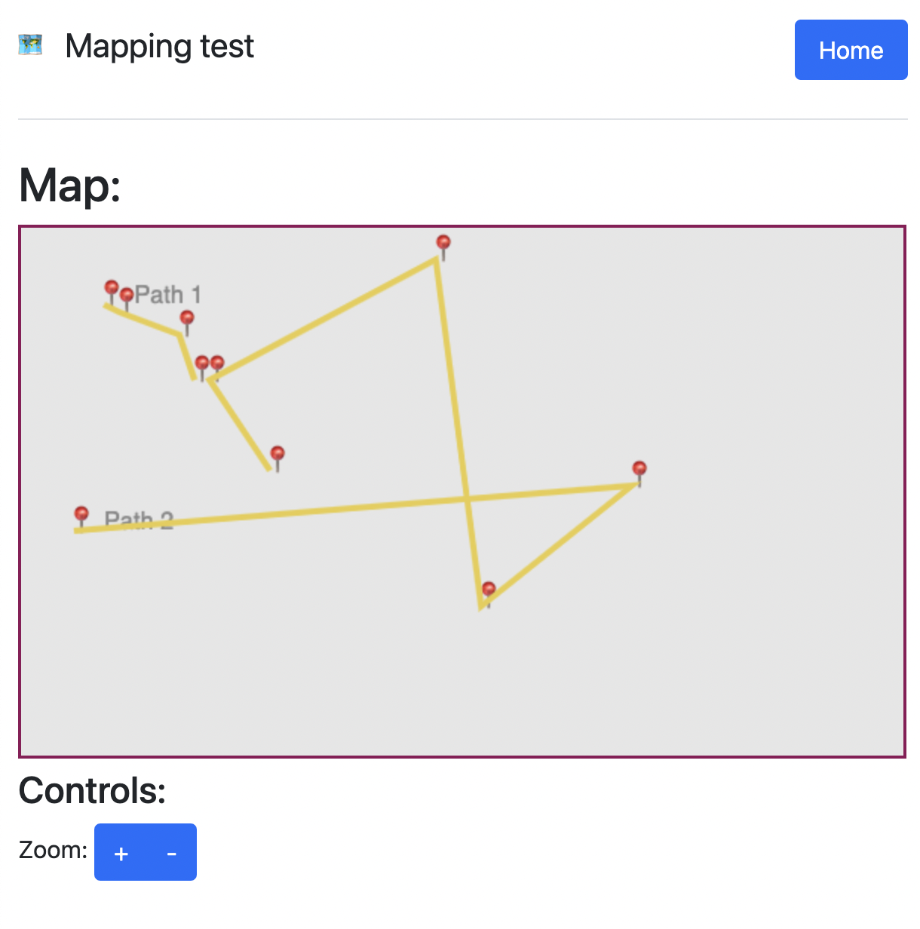

## Modelling

During the analysis stage of my project having completed the prototype, I decided to draw up a project structure model, included below, describing the planned components of the project and how I expected them to interact.

**High level project structure**

This document outlines an initial plan for the main components of my NEA, and how these will interact.

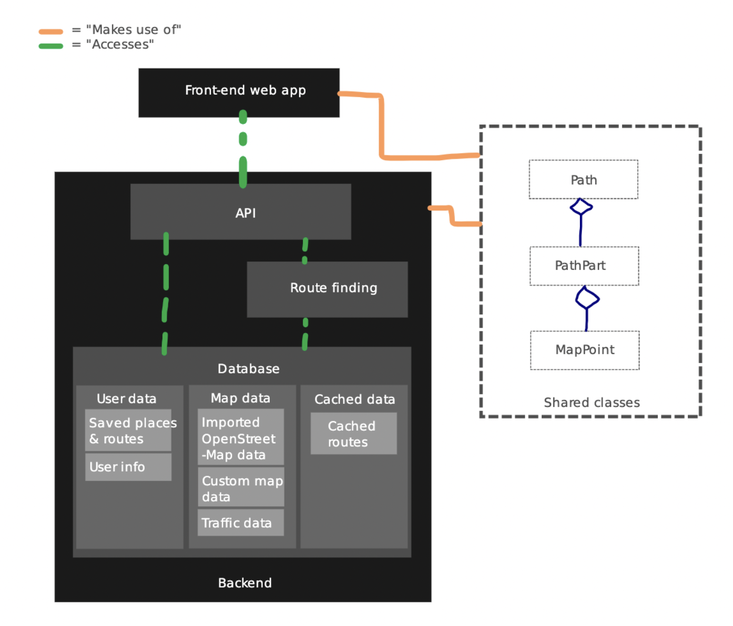

**The frontend**

The frontend will be a web app built using JavaScript, HTML5 and CSS3 technologies. It will

* Display a map that is scalable and translatable
* Communicate with the backend using an API
* Support a variety of devices such as desktops, tablets and smartphones

It will share many of the data structures that are used on the backend representing map elements and paths. It will require extensive testing to be able to ensure it can reliably perform these functions, where serving as a web app will make user testing easier.

**The backend**

The backend will be built in JavaScript using the Node.JS framework. At its most basic level, it will:

* Be able to read OpenStreetMap data that will be imported into a database
* Serve this data via an API to the frontend
* Calculate paths and serve this via an API to the frontend

It will therefore require a database and the use of path theory which I will have to research.

# Documented design

The design of my project is organised into three main components:

1. **convertFromOSM.js**

This is manually ran in order to convert data from a source OSM XML file into the custom database format (db.json) that the project uses. This can take up to around 5 minutes as it is often a large dataset. Throughout development I have been using OSM XML map data of Cambridgeshire that is imported using this script with success.

The resultant db.json is in a normalised form, and is significantly faster to process than just the OSM, as it does not have the same XML overhead and can be read natively into a JavaScript object on both the client and server, both of which use JavaScript.

1. **The server**

This is the largest part of the project and is responsible for operating an API from which the client requests views of the database using queries, as well as conducting searches and route finding. It is additionally responsible for hosting the web application.

1. **The web application**

This is responsible for requesting and displaying map data to the user, as well as presenting the user interface.

A diagram of these components and how they interact is shown below:

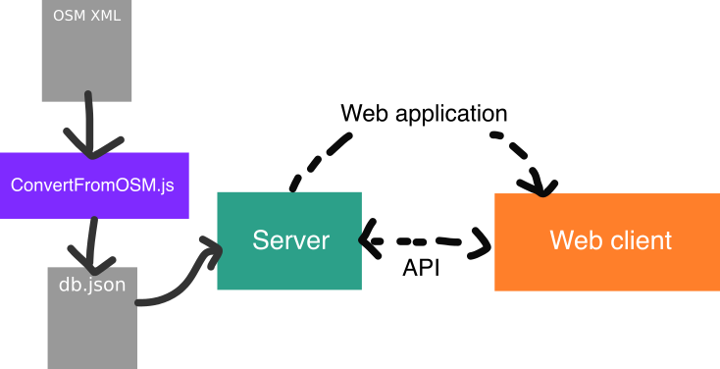

## Main data containers

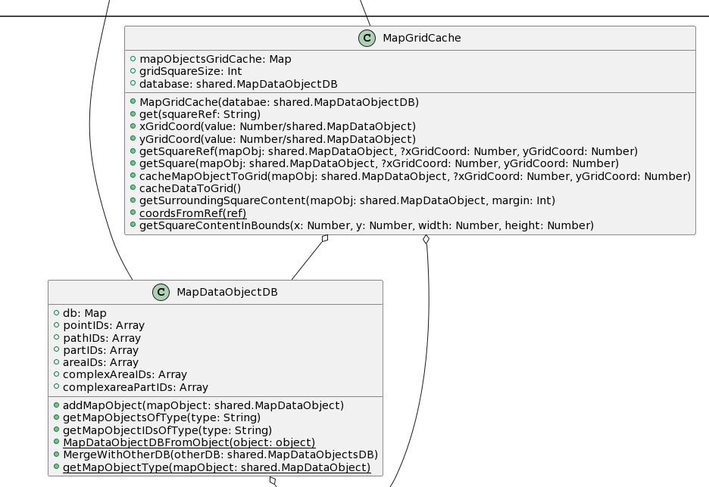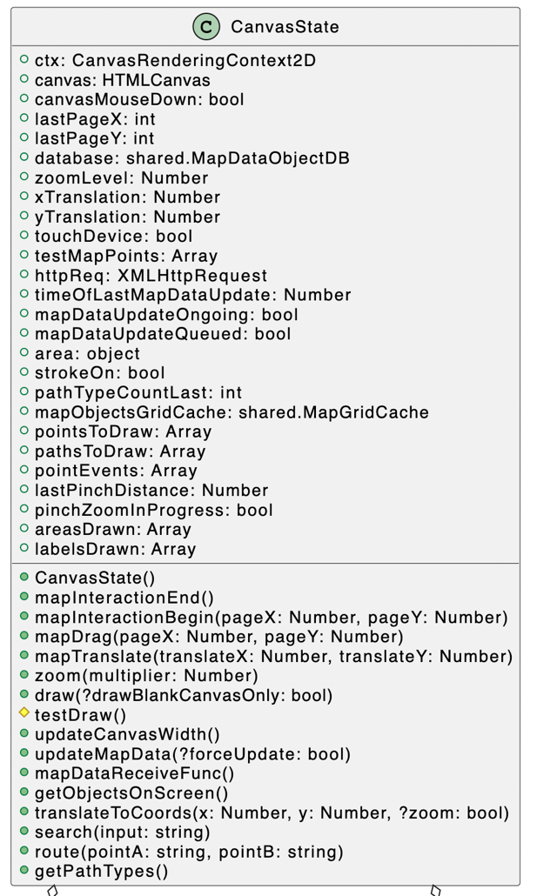

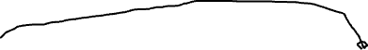

The CanvasState class is specific to the client and contains all the data and methods necessary to draw the map to the screen, with methods to request data from the server.

CanvasState augments MapGridCache and MapDataObjectDB, data structures that are also used on the server. The grid cache uses a hash map to map a square on a grid to the map objects currently being displayed on the grid, while the object DB is a custom database implementation that stores map objects so they can be accessed and queried, on both the server and client.

## A picture containing text Description automatically generatedMap objects

The shared map objects represent the server representation of map elements such as points and paths, with those properties and methods that are required by the server. The client inherits from these shared map objects to add those properties and methods necessary to draw them to screen, with the exception of ComplexAreaPart which has to be fully duplicated from the shared structures unlike the other classes, because otherwise it inherits shared.Area without drawing functions, rather than just Area with drawing functions.

## Database layout

The database used by my project is organised into keys, where each key is the unique ID of a map object, and the beginning of each ID indicates the table it is a part of. These are: POINT, PATH, PART, AREA, COMPLEX-AREA, and COMPLEX-AREA-PART. For example, an ID for a specific point might be POINT_123AbC. Where the last characters uniquely identify the point.

This database is in JSON key-value pairs as a file but is stored as a hash-map when loaded into memory both on the server and client.

The database caches the specific IDs that are in use for each map object type, so that all map objects of a specific type can quickly be iterated through, for example when conducting a search.

Map objects reference map objects in other “tables” using their IDs as foreign keys. For example, an Area contains an array of point IDs that make up that area.

## Path finding pseudocode

One of the key features of my project is route finding of real world map data. Pseudocode detailing the algorithm used in my implementation is explained below:

// This function is called when a API request to find a route between two points is

// received.

START FUNCTION findRoute(startingPointSearchTerm, destinationPointSearchTerm, database, gridCache)

// Conduct searches of the search terms to find their corresponding points

startingPointID = Search(startingPointSearchTerm, database)

destinationPointID = Search(destinationPointSearchTerm, database)

startingPoint = database.get(startingPointID)

destinationPoint = database.get(destinationPointID)

// Get the point nearest to found points that is on a highway

// From which we can conduct routing. We limit the types of highways

// that we can route using to decrease nodes and therefore

// decrease processing time into reasonable bounds

startingPoint = nearestHighwayPoint(startingPoint, database, gridCache)

destinationPoint = nearestHighwayPoint(destinationPoint, database, gridCache)

// Begin dijkstra's now that we have our starting and destination points finalised

// Define sets

visitedNodes = new HashMap()

unvisitedNodes = new HashMap()

// Set distance of starting point to 0

startingPoint.distance = 0

allDatabasePaths = database.getMapObjectsOfType("PATH")

FOR EACH path IN allDatabasePaths

IF isAcceptedHighway(path)

FOR EACH point IN path

// Set default properties for all nodes at start of dijkstra

point.distance = Infinity

point.visited = false

point.parentNode = None

unvisitedNodes[point.ID] = point

END FOR

END IF

END FOR

currentNode = startingPoint

WHILE destinationPoint.visited == false DO

// Get same points in same 10x10 square as currentNode

neighbours = []

neighbours += gridCache.get(currentNode.x, currentNode.y)

neighbours += getPathContainingPoint(currentNode).getPointAfter(currentNode)

neighbours += getPathContainingPoint(currentNode).getPointBefore(currentNode)

// If all neighbours have Infinite distance, a route has not been

// successfully found

IF EVERY neighbour IN neighbours HAS neighbour.distance == Infinity

return []

END IF

FOR EACH neighbour IN neighbours

// Calculate the distance to each neighbour, changing its recorded distance if this

// calculated value is less than that recorded

tentativeDistance = currentNode.distance + distanceToPoint(neighbour)

IF tentativeDistance < neighbour.distance THEN

neighbour.distance = tentativeDistance

END IF

// Set current node as the parent of the neighbour to allow for

// back-tracking

IF neighbour.ID != currentNode.ID THEN

neighbour.parentID = currentNode.ID

END IF

END FOR

// We have now examined all neighbours of this node, mark it as visited

currentNode.visited = true

// Remove from unvisitedNodes so we don't visit it again

unvisitedNodes.delete(currentNode.ID)

// Add to visited nodes so that we can back track later to find route

visitedNodes[currentNode.ID] = currentNode

// Set next current node to unvisited node with smallest distance

nextNode = EMPTY

FOR EACH node IN unvisitedNodes

IF nextNode == EMPTY OR node.distance < nextNode.distance THEN

nextNode = node

END IF

END FOR

currentNode = nextNode

END WHILE

// The algorithm should have now found a route, now we back-track in order

// to record this route

currentNode = destinationPoint

fastestPath = []

WHILE currentNode != startingPoint

fastestPath += currentNode

currentNode = visitedNodes[currentNode.parentID]

END WHILE

return fastestPath.reverse()

END FUNCTION

START FUNCTION Search(searchTerm, database)

searchResults = [];

// Iterate through search index, adding a score for each map object

// depending on its calculated relevance to search term.

FOR EACH mapObject IN this.searchIndex

searchConfidence = 0

// If the search term matches the exact ID of the object

// Rise this to the top of the results with a high

// search confidence

IF (mapObject.ID == searchTerm)

searchConfidence += 20;

ELSE

// Otherwise, score by the amount of times the term appears in the metadata

searchConfidence += OCCURRENCES OF searchTerm IN apObject.metadata;

END IF

// If the map object explicitly defines a place such as a town and

// It already matches the search term, increase its score so

// it shows up higher. This is because if someone searches for

// something like "Cambridge", we want to return the City, not

// some random location 15 miles away that happens to have

// "Cambridge" in its name.

IF (mapObject.metadata DESCRIBES AS "place" AND searchConfidence > 0)

searchConfidence += 15

END IF

ADD [mapObject, searchConfidence] to searchResults

END FOR

SORT searchResults by searchConfidence DESCENDING // Show highest scoring results first

result = FIRST entry IN searchResults WHERE entry.mapObject OF TYPE "POINT" || "PATH"

IF result == EMPTY

THROW ERROR

ELSE

IF result.mapObject OF TYPE "PATH"

result.mapObject = getPathMidpoint(result.mapObject)

END IF

RETURN result.mapObject.ID

END IF

END FUNCTION

## HCI

This section will demonstrate how a user interacts with the application, by using screenshots and explanations.

When the user first loads the website, the website will make its first request to the server for map data, which will then be displayed on screen, as shown below:

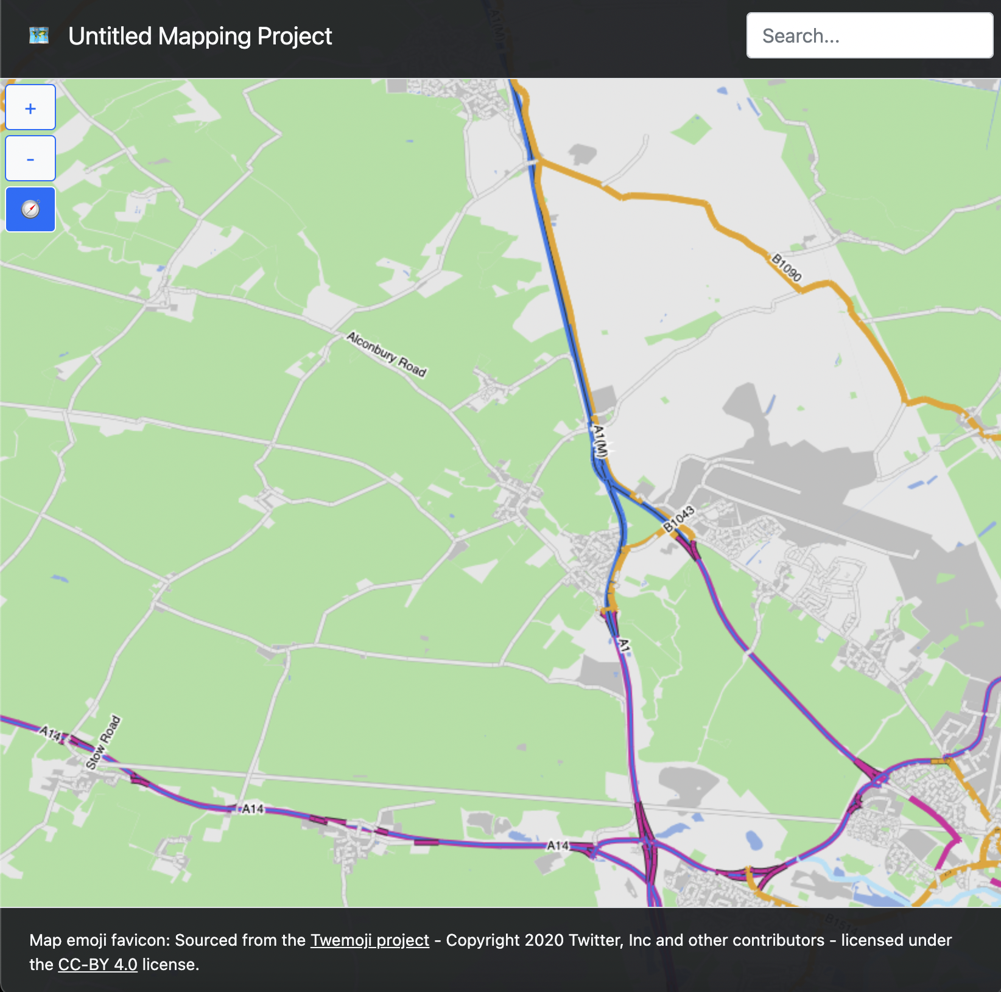

The user is free to pan this map much like on Google maps, and zoom using the +/- buttons to the left of the screen.

As the user moves about the map, new map data for this view is progressively loaded in from the server.

The user can use the search box at the top right of the screen to conduct a search of points and paths in the database, simply typing their search term and pressing enter, which will cause a draggable dialog box to appear, like that shown below:

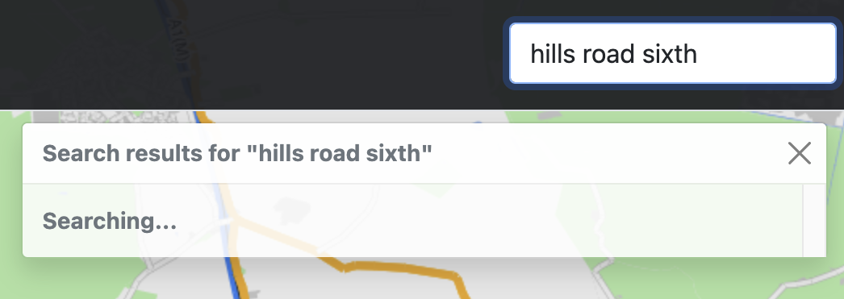

Results can then be displayed in the same dialog, translating the map to a view showing all the results:

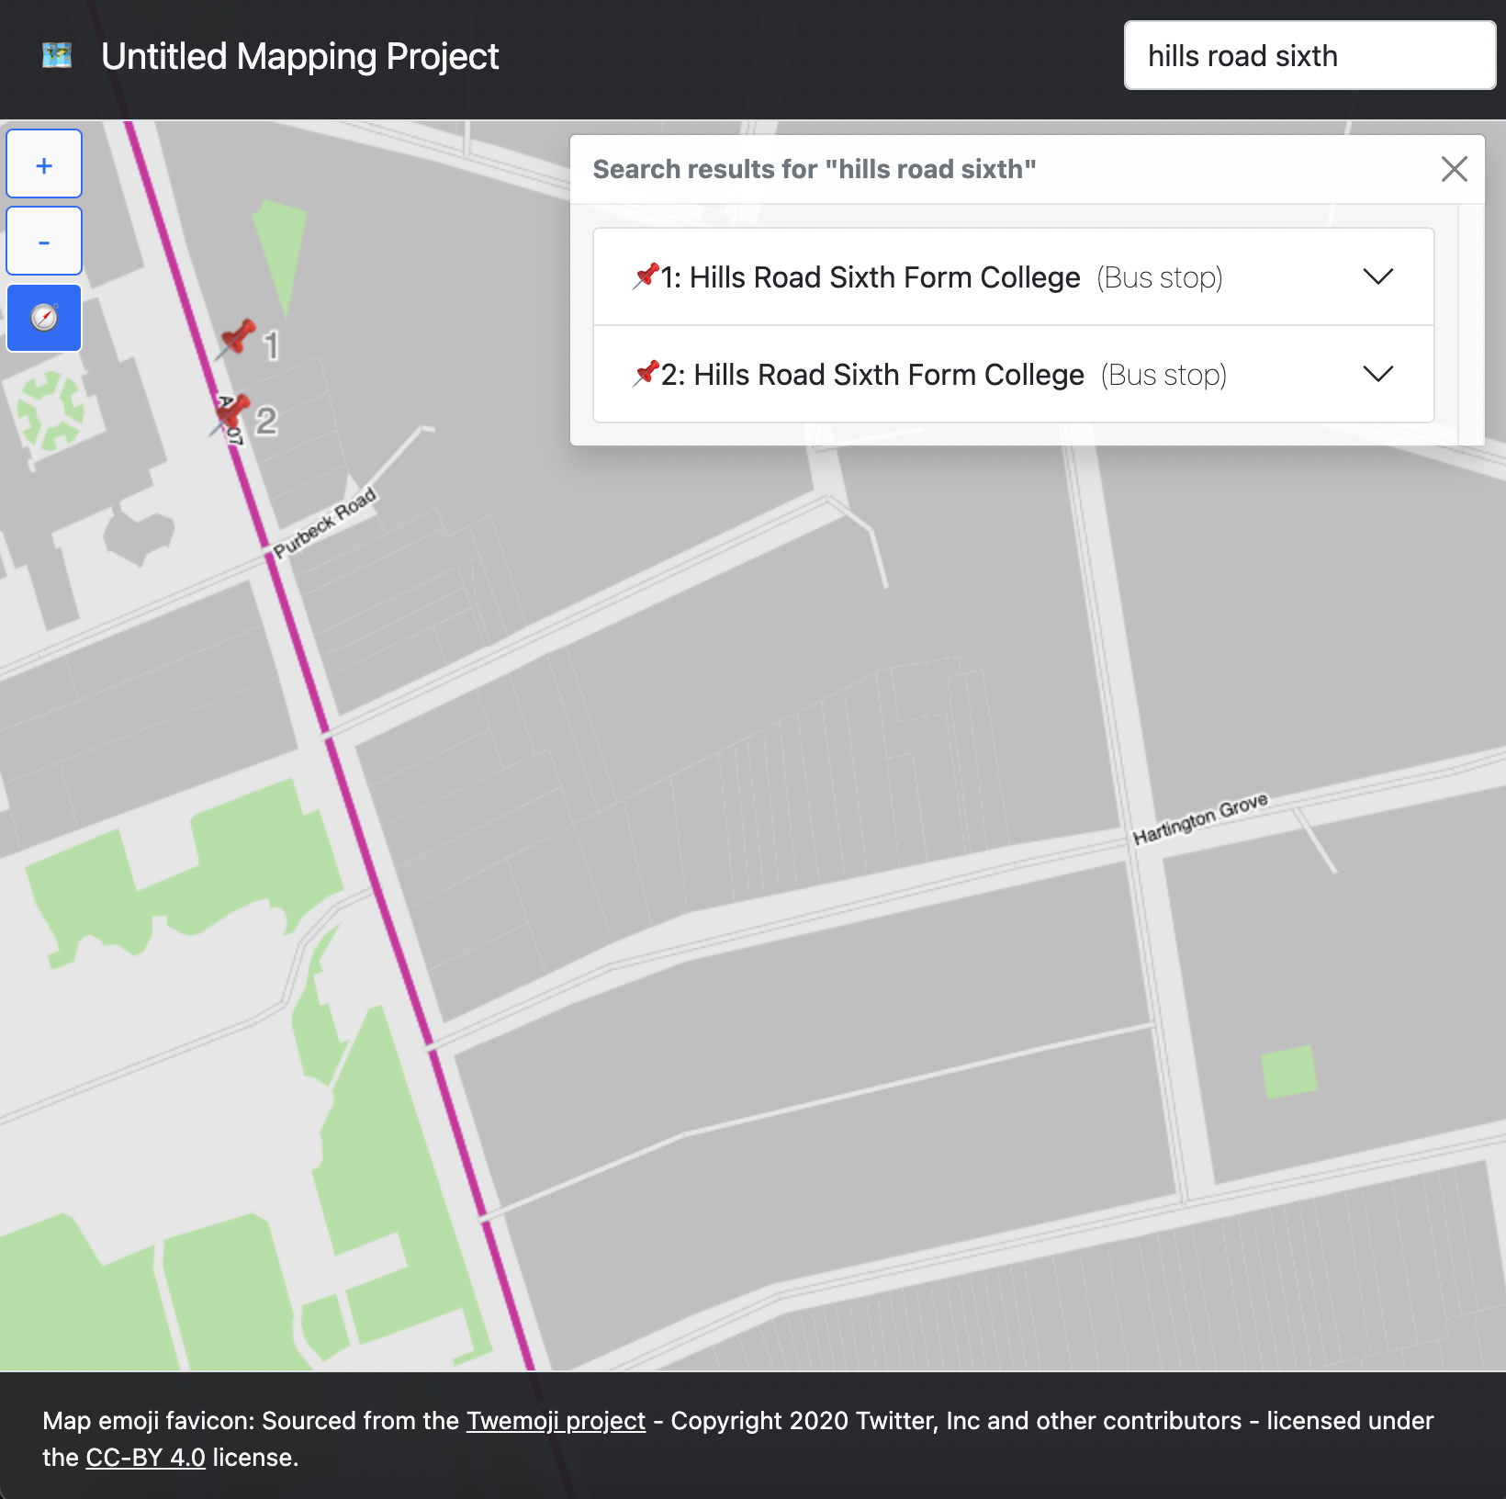

These results can then be selected to view additional information and translate the map to a specific point.

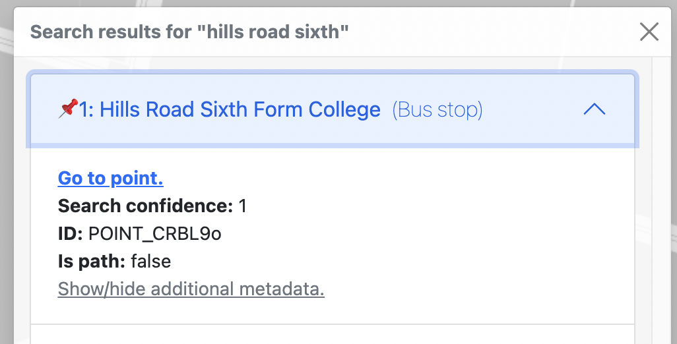

While the “Show/hide additional metadata” button can be selected to show additional metadata, sourced from OSM.

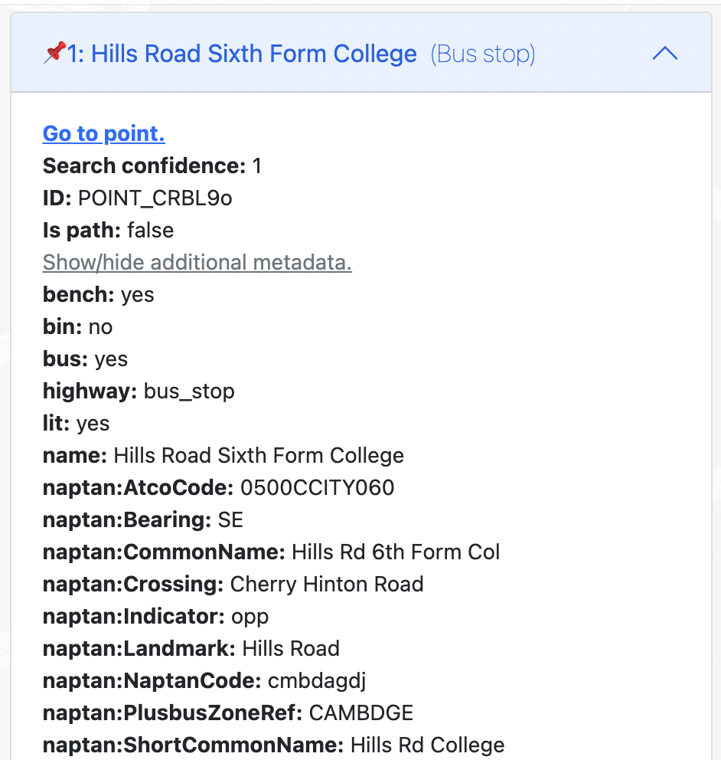

The compass button on the left of the display is used to show a dialog to find a route between two points.

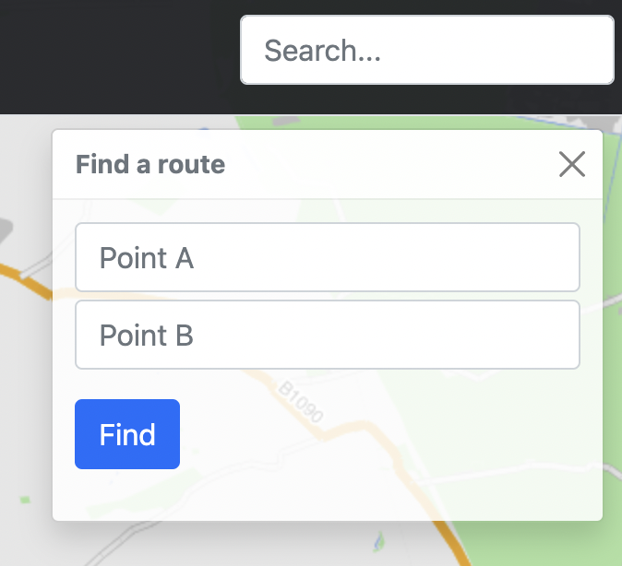

With search terms entered in both text boxes, the find button can be pressed and the status of the operation is displayed, while the server processes the request.

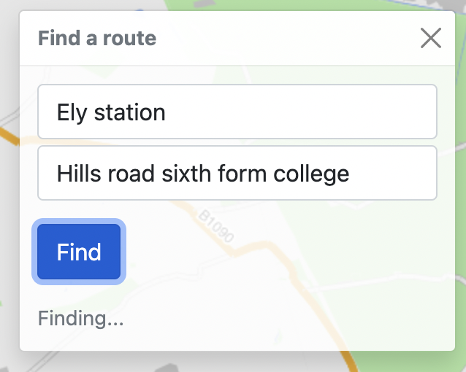

And a route should then be displayed on the map.

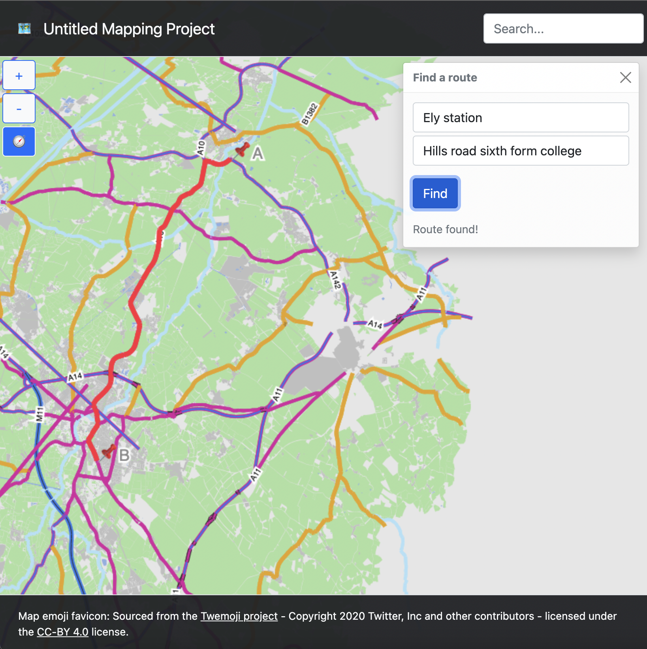

Both the search and route-find draggable dialogs can be displayed at the same time in addition.

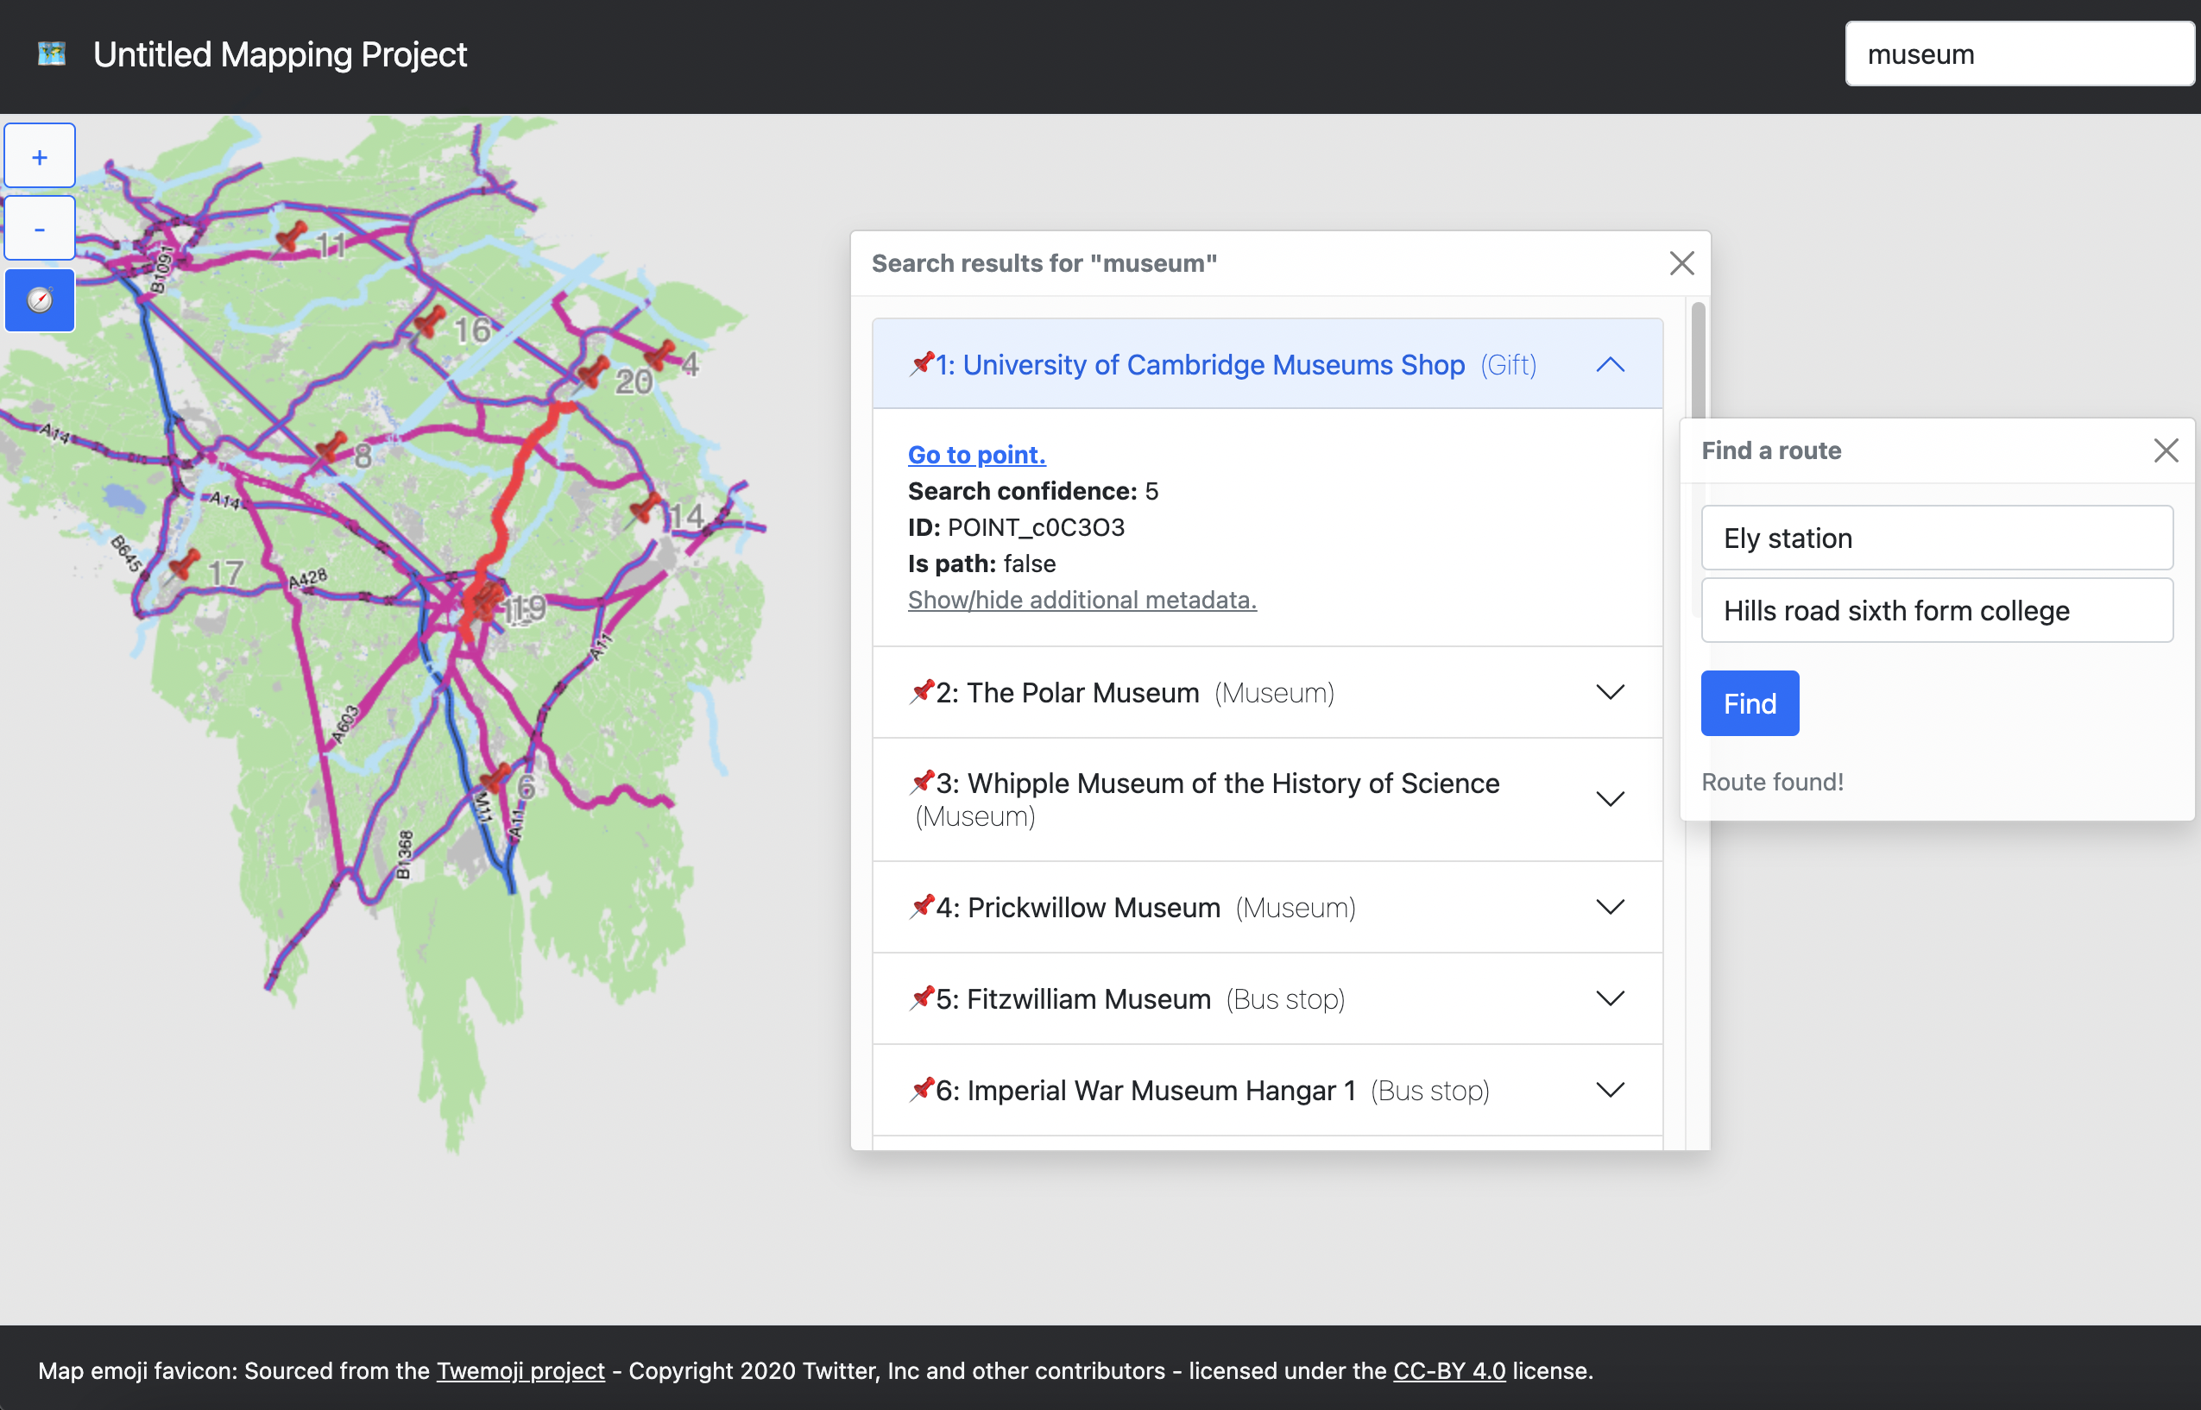

# Technical solution

## Web client

**src/web/index/index.js**

canvasState = undefined;

debug_displayAreasDrawn = false;

debug_drawAllHighwayLabelsTest = true;

debug_drawHighwayLabels_smart = true;

debug_testDB = false;

globalPoint=null;

class CanvasState {

/** The {CanvasRenderingContext2D} that is used on the canvas */

ctx

/** The canvas element that displays the map */

canvas

/** Indicates whether the mouse button is down */

canvasMouseDown = false

/** Indicates the last recorded mouse position relative to the page in X */

lastPageX = -1

/** Indicates the last recorded mouse position relative to the page in Y */

lastPageY = -1

/** The database containing map points */

database = new shared.MapDataObjectDB()

/** A {int} multiplier to represent the zoom level */

zoomLevel = 1

/** {int} representing how the map has been translated in x */

xTranslation = 0

/** {int} representing how the map has been translated in y */

yTranslation = 0

touchDevice = false

/** An array of test nodes that should be drawn to screen, and nothing else, when draw() is called if not null */

testMapPoints = null

/** Http request */

httpReq

/** Time of last map data update */

timeOfLastMapDataUpdate = 0;

/** Map data update ongoing flag */

mapDataUpdateOngoing = false

/** Map data update queued flag */

mapDataUpdateQueued = false;

/** Contains details about last/current area drawn to screen */

area

/** Indicates wether stroke is on */

stokeOn = false;

/** Stores the value of the last number of path types drawn */

pathTypeCountLast = 0;

/** Maps objects onto a grid made of 10x10 squares so can be queried more quickly */

mapObjectsGridCache;

/** Array of points to draw (e.g, search markers are added to this) */

pointsToDraw = []

/** Array of paths to draw over other paths (e.g. routes) */

pathsToDraw = []

/** Stores Events for pinch gestures */

pointEvents = []

/** Store previous distance between digits */

lastPinchDistance = 0;

/** Indicates wether a pinch zoom is in progress */

pinchZoomInProgress = false;

/** Stores details of areas drawn to screen */

areasDrawn = [];

/** Drawn labels */

labelsDrawn = [];

constructor () {

this.canvas = document.getElementById("mapCanvas");

this.ctx = this.canvas.getContext('2d');

this.canvas.style.cursor = "default";

// Zoom functionality

document.getElementById("zoom-in").onclick = (event) => {

this.zoom(1);

};

document.getElementById("zoom-out").onclick = (event) => {

this.zoom(-1);

};

// Translation functionality

this.canvas.ontouchstart = (event) => {

this.touchDevice = true;

this.mapInteractionBegin(event.targetTouches[0].pageX, event.targetTouches[0].pageY);

}

this.canvas.onmousedown = (event) => {

if (!this.touchDevice) {

this.mapInteractionBegin(event.pageX, event.pageY);

}

}

this.canvas.ontouchend = () => this.mapInteractionEnd();

this.canvas.onmouseup = () => this.mapInteractionEnd();

this.canvas.ontouchmove = (event) => {

if (event.targetTouches.length == 1 && !this.pinchZoomInProgress)

this.mapDrag(event.targetTouches[0].pageX, event.targetTouches[0].pageY);

}

this.canvas.onmousemove = (event) => {

if (this.canvasMouseDown && !this.pinchZoomInProgress)

this.mapDrag(event.pageX, event.pageY);

}

this.canvas.onmouseenter = (event) => {

this.canvas.style.cursor = "grab";

}

this.canvas.onmouseleave = (event) => {

this.canvas.style.cursor = "default";

}

// Code to support pinch zoom based on https://developer.mozilla.org/en-US/docs/Web/API/Pointer_events/Pinch_zoom_gestures by Mozilla Contributors, licensed under CC-BY-SA 2.5

this.canvas.onpointerdown = (event) => {

canvasState.pointEvents.push(event)

}

this.canvas.onpointermove = (event) => {

// Find this event in the cache and update its record with this event

for (var i = 0; i < canvasState.pointEvents.length; i++) {

if (event.pointerId == canvasState.pointEvents[i].pointerId) {

canvasState.pointEvents[i] = event;

break;

}

}

// If 2 fingers zooming

if (canvasState.pointEvents.length == 2) {

canvasState.pinchZoomInProgress = true;

var curDiff = Math.abs(canvasState.pointEvents[0].clientX - canvasState.pointEvents[1].clientX);

if (this.lastPinchDistance != 0) {

canvasState.zoomLevel *= (curDiff/canvasState.lastPinchDistance);

console.log((curDiff/canvasState.lastPinchDistance));

canvasState.draw();

}

canvasState.lastPinchDistance = curDiff;

}

}

this.canvas.onpointerup = (eventA) => {

canvasState.pointEvents = canvasState.pointEvents.filter(eventB => eventA.pointerId != eventB.pointerId);

if (canvasState.pointEvents.length == 0) {

canvasState.updateMapData();

canvasState.pinchZoomInProgress = false;

};

}

// Redraw on window resize to make sure canvas is right size

window.addEventListener('resize', () => this.draw());

// Set up map grid cache

this.mapObjectsGridCache = new shared.MapGridCache(this.database)

}

mapInteractionEnd() {

this.lastPageX = -1;

this.lastPageY = -1;

this.canvasMouseDown = false;

if (this.canvas.style.cursor == "grabbing")

this.canvas.style.cursor = "grab";

this.updateMapData();

}

mapInteractionBegin(pageX, pageY) {

this.lastPageX = pageX;

this.lastPageY = pageY;

this.canvasMouseDown = true;

if (this.canvas.style.cursor == "grab")

this.canvas.style.cursor = "grabbing";

}

mapDrag(pageX, pageY) {

var relativeMouseX = pageX - this.lastPageX;

var relativeMouseY = pageY - this.lastPageY;

this.mapTranslate(relativeMouseX, relativeMouseY);

this.lastPageX = pageX;

this.lastPageY = pageY;

this.draw();

}

mapTranslate(translateX, translateY) {

this.xTranslation += (translateX / this.zoomLevel);

this.yTranslation += (translateY / this.zoomLevel);

}

/**

* Method to change the zoom level of the displayed map

* @param {int} multiplier The multiplier to change the zoom by, normally either -1 or 1

*/

zoom(multiplier) {

let zoomChange = 1 + (0.3 * multiplier);

if (this.zoomLevel + zoomChange < 0)

return;

this.zoomLevel *= zoomChange;

this.draw();

this.updateMapData();

}

/**

* Calls functions to draw path to screen

*/

draw(drawBlankCanvasOnly=false) {

// Update canvas width

this.updateCanvasWidth();

// Clear canvas

this.ctx.clearRect(0, 0, this.canvas.width, this.canvas.height);

// Fill background

this.ctx.fillStyle = "#e6e6e6";

this.ctx.fillRect(0, 0, this.canvas.width, this.canvas.height);

if (drawBlankCanvasOnly) return;

let objectsOnScreen = this.getObjectsOnScreen();

let topLayerAreas = [];

let areas = objectsOnScreen["AREA"];

// Draw lower layer areas, adding lower layer areas to topLayerAreas to draw later

if (areas != undefined)

for (let i = 0; i < areas.length; i++) {

const area = areas[i];

if (area.metadata.areaType["first_level_descriptor"] == "land") // TODO: Create "layer" property and read from this instead

area.draw(this);

else

topLayerAreas.push(area);

}

for (let i = 0; i < topLayerAreas.length; i++) {

const area = topLayerAreas[i];

area.draw(this);

}

let complexAreas = objectsOnScreen["COMPLEX-AREA"];

if (complexAreas != undefined)

for (let i = 0; i < complexAreas.length; i++) {

const complexArea = complexAreas[i];

complexArea.draw();

}

if (this.testMapPoints != null) {

// Halt drawing, call test draw function instead, typical drawing will not be executed

this.#testDraw();

return;

}

let paths = objectsOnScreen["PATH"];

if (paths != undefined)

for (let i = 0; i < paths.length; i++) {

let path = paths[i];

let acceptedPathTypes = this.getPathTypes();

// Only plot line if is one of accepted path types for zoom level

if (acceptedPathTypes.includes(path.metadata.pathType["second_level_descriptor"])

|| acceptedPathTypes.includes(path.metadata.pathType["first_level_descriptor"]))

path.plotLine(this);

}

// this.database.getMapObjectsOfType("POINT").forEach(point => point.drawPoint(this));

// Clear drawn labels

this.labelsDrawn = [];

// Draw highway labels

if (paths != undefined)

for (let i = 0; i < paths.length; i++) {

const path = paths[i];

path.drawLabel();

}

// Draw points and paths to draw

this.pointsToDraw.forEach(point => point.drawPoint());

this.pathsToDraw.forEach(path => path.plotLine());

if (debug_displayAreasDrawn) debug_displayAreasDrawnFunc();

}

#testDraw() {

this.testMapPoints.forEach(mapPoint => {

mapPoint.drawPoint(this);

});

}

/**

* Updates the width of the canvas displayed on screen

*/

updateCanvasWidth() {

// Resize to 100% (html decleration does not work)

this.canvas.width = window.innerWidth;

this.canvas.height = window.innerHeight;

}

updateMapData(forceUpdate=false) {

// Assemble types of paths to query based on zoom level

let pathTypes = this.getPathTypes();

if (pathTypes.length > this.pathTypeCountLast) {

this.pathTypeCountLast = pathTypes.length;

// Force an update as more path types have been requested

forceUpdate = true;

}

// Only continue if forceUpdate flag is set, or more than 500ms since last map data update and mapDataUpdateOngoing flag is not set

if (!forceUpdate && (this.mapDataUpdateOngoing || Date.now() - this.timeOfLastMapDataUpdate < 500)) {

if (!this.mapDataUpdateQueued) {

// Try again in 1s time

setTimeout(() => {

this.mapDataUpdateQueued = false;

this.updateMapData();

}, 1000);

this.mapDataUpdateQueued = true;

}

return;

}

this.mapDataUpdateOngoing = true;

canvasState.area = {

x: -canvasState.xTranslation - 500,

y: -canvasState.yTranslation - 500,

height: (getAbsoluteHeight(canvasState.canvas)/canvasState.zoomLevel) + 500,

width: (getAbsoluteWidth(canvasState.canvas)/canvasState.zoomLevel) + 500,

pathTypeCount: pathTypes.length

};

// Check map area hasn't already been drawn

let hasBeenDrawn = false;

for (let i = 0; i < this.areasDrawn.length; i++) {

const areaDrawn = this.areasDrawn[i];

hasBeenDrawn = hasBeenDrawn || (areaDrawn.pathTypeCount >= canvasState.area.pathTypeCount &&

(canvasState.area.x >= areaDrawn.x && canvasState.area.x + canvasState.area.width <= areaDrawn.x + areaDrawn.width

&& canvasState.area.y >= areaDrawn.y && canvasState.area.y + canvasState.area.height <= areaDrawn.y + areaDrawn.height))

if (hasBeenDrawn) break;

}

if (forceUpdate || !hasBeenDrawn) {

// Make request

let testingDBurl = `/api/GetTestDB`;

let wholeDBurl = `/api/GetDBfromFile`;

let testURLnoMapArea = `/api/GetDBfromQuery?pathTypes=[%22motorway%22,%22primary%22,%22trunk%22,%22primary_link%22,%22trunk_link%22,%22river%22]&&noMapAreaFilter=true`;

let testURLlimitedArea = `/api/GetDBfromQuery?pathTypes=[%22motorway%22,%22primary%22,%22trunk%22,%22primary_link%22,%22trunk_link%22,%22river%22]&x=48.1699954728&y=9784.703958946639&height=1317.4001900055023&width=1271.3921765555658&excludeAreas=[]`;

let normalURL = `/api/GetDBfromQuery?pathTypes=${JSON.stringify(pathTypes)}&area=${JSON.stringify(canvasState.area)}`;

let currentURL;

if (debug_testDB) currentURL = testingDBurl;

else currentURL = normalURL;

this.httpReq.open("GET", currentURL);

this.httpReq.send();

// Display loading indicator

document.getElementById("loading-indicator-container").style.display = "block";

} else {

this.mapDataUpdateOngoing = false;

}

}

mapDataReceiveFunc = () => {

// Request returns db as uninstanciated object

// we need to convert this

var simpleDB = JSON.parse(canvasState.httpReq.response);

if(shared.debug_on)

console.log(`Received JSON has ${Object.keys(simpleDB.db).length} items.`)

var database = shared.MapDataObjectDB.MapDataObjectDBFromObject(simpleDB);

canvasState.database.mergeWithOtherDB(database);

this.mapObjectsGridCache.cacheDataToGrid();

if(shared.debug_on)

console.log(`Computed database currently has ${canvasState.database.getMapObjectsOfType("PATH").length} paths.`);

// Draw

canvasState.draw();

// Add area drawn to list of areas drawn

canvasState.areasDrawn.push(Object.assign({}, canvasState.area));

// Update time since last map data update

canvasState.timeOfLastMapDataUpdate = Date.now();

// Update map data update ongoing flag

canvasState.mapDataUpdateOngoing = false;

// Hide loading indicator

document.getElementById("loading-indicator-container").style.display = "none";

}

/**

* Returns those map objects on screen as per mapObjectsGridCache.

*/

getObjectsOnScreen() {

var objectsOnScreen = {};

let xTranslation = canvasState.xTranslation;

let yTranslation = canvasState.yTranslation;

let zoomLevel = canvasState.zoomLevel;

let gridSquareSize = canvasState.mapObjectsGridCache.gridSquareSize;

let xInitial = Math.floor((-xTranslation)/gridSquareSize)*gridSquareSize - 2*gridSquareSize;

let xIncrement = gridSquareSize;

let xLimit = Math.floor(((canvasState.canvas.width/(zoomLevel*1.5)) - xTranslation)/gridSquareSize)*gridSquareSize + 2*gridSquareSize;

let yInitial = Math.floor((-yTranslation)/gridSquareSize)*gridSquareSize - 2*gridSquareSize;

let yIncrement = gridSquareSize;

let yLimit = Math.floor(((canvasState.canvas.height/zoomLevel) - yTranslation)/gridSquareSize)*gridSquareSize + 2*gridSquareSize;

var objectIDsAdded = new Map();

for (let x = xInitial;

x < xLimit;

x += xIncrement) {

for (let y = yInitial;

y < yLimit;

y += yIncrement) {

let square = canvasState.mapObjectsGridCache.get(`${x}x${y}`);

if (square != undefined) {

for (let i = 0; i < square.length; i++) {

const mapObjectID = square[i];

if (!objectIDsAdded.get(mapObjectID)) {

let type = mapObjectID.slice(0, mapObjectID.indexOf("_"));

if (objectsOnScreen[type] == undefined) objectsOnScreen[type] = [];

objectsOnScreen[type].push(this.database.db.get(mapObjectID));

objectIDsAdded.set(mapObjectID, true);

}

}

}

}

}

return objectsOnScreen;

}

translateToCoords(x,y,zoom=true) {

if (zoom) canvasState.zoomLevel = 4;

canvasState.xTranslation = -x + (75 / canvasState.zoomLevel);

canvasState.yTranslation = -y + (200 / canvasState.zoomLevel);

canvasState.draw();

}

/**

* Initiates a search

* @param {string} input search term

*/

search = (input) => {

var resultsAccordion = document.getElementById("results-accordion");

resultsAccordion.innerHTML = "<strong class='text-muted'>Searching...</strong>";

document.getElementById("results-title").innerText = `Search results for "${input}"`;

// Make search results draggable

$("#results").draggable({cancel: "#results-accordion"});

// Show results dialog

let resultsEl = document.getElementById("results");

(new bootstrap.Toast(resultsEl)).show();

let http = new XMLHttpRequest();

http.addEventListener("load", () => {

if (http.responseText.indexOf("error") == 0) {

resultsAccordion.innerHTML = "<strong class='text-muted'>An error occurred :-(</strong>";

return;

};

try {

let responseArray = JSON.parse(http.responseText);

canvasState.pointsToDraw = [];

// Display search results

let points = [];

for (let i = 0; i < responseArray.length; i++) {

const mapObject = responseArray[i].mapObject;

let point;

if (mapObject.ID.indexOf("POINT") == 0)

point = MapPoint.mapPointFromObject(mapObject);

else if (mapObject.ID.indexOf("PATH") == 0) {

let path = Path.pathFromObject(mapObject);

path.midpoint = MapPoint.mapPointFromObject(mapObject.midpoint);

point = path.midpoint;

// Add metadata of path to point

point.metadata.path = path.metadata;

}

point.searchScore = responseArray[i].score;

// // If no label available, don't display if search confidence is below % of max

// if (points.length > 0 && point.label == point.ID && point.searchScore < points[0].searchScore * 0.6) continue;

points.push(point);

}

resultsAccordion.innerHTML = "";

if (points.length == 0) resultsAccordion.innerHTML = "<strong class='text-muted'>No results found :-(</strong>";

else resultsAccordion.innerHTML = "";

for (let i = 0; i < points.length; i++) {

const point = points[i];

let pointToDraw = MapPoint.generatePointWithLabel(point.x, point.y, `${i+1}`);

if (!canvasState.pointsToDraw.includes(pointToDraw));

canvasState.pointsToDraw.push(pointToDraw);

resultsAccordion.innerHTML += `

<div class="accordion-item">

<h2 class="accordion-header">

<button class="accordion-button collapsed" type="button" data-bs-toggle="collapse" data-bs-target="#collapse${i}">

<div>📌${i+1}: ${point.label} <span class="fw-lighter">&nbsp;(${point.locationType})</span></div>

</button>

</h2>

<div id="collapse${i}" class="accordion-collapse collapse">

<div class="accordion-body">

<a href="javascript:canvasState.translateToCoords(${point.x},${point.y})">

<strong>Go to point.</strong></a>

<br/><strong>Search confidence:</strong> ${point.searchScore}

<br/><strong>ID:</strong> ${point.ID}

<br/><strong>Is path:</strong> ${point.metadata.path != undefined}

<br/>

<a class="link-secondary" data-bs-toggle="collapse" href="#metadata-collapse-${i}" role="button">

Show/hide additional metadata.

</a>

<div class="collapse" id="metadata-collapse-${i}">

${point.metadataHTML}

</div>

</div>

</div>

</div>`;

if (point.metadata.path != undefined) point.metadata.path = undefined;

}

if (points.length > 0) {

let bounds = shared.getBoundsOfPointArray(points);

canvasState.zoomLevel = bounds.zoomLevel;

canvasState.translateToCoords(bounds.minX, bounds.minY, false);

canvasState.draw();

canvasState.updateMapData();

}

} catch (err) {console.log(err)}

});

http.open("GET", `/api/PointSearch?searchTerm="${input}"`);

http.send();

}

route(pointA, pointB) {

let http = new XMLHttpRequest();

http.addEventListener("load", () => {

if (http.responseText.indexOf("error") == 0 || http.responseText == "[]") {

let errorText = "An error occurred.";

if (http.responseText == "error: input")

errorText = "Could not find points.";

if (http.responseText.indexOf("error: highway point undefined.") == 0)

errorText = "One or more of the points is not near enough to an accepted highway to be able to find a route.";

if (http.responseText == "[]")

errorText = "Unable to find route.";

document.getElementById("route-status").innerText = errorText + " :-(";

return

};

let responseArray = JSON.parse(http.responseText);

let pointArray = responseArray.map(simplePoint => shared.MapPoint.mapPointFromObject(simplePoint));

let path = Path.connectSequentialPoints(pointArray, canvasState.database);

path.metadata.pathType = {};

path.metadata.pathType["second_level_descriptor"] = "returned_route";

canvasState.pathsToDraw = [path];

let bounds = shared.getBoundsOfPointArray(path.getAllPointsOnPath(canvasState.database));

canvasState.zoomLevel = bounds.zoomLevel;

canvasState.translateToCoords(bounds.minX, bounds.minY, false);

let pointA = MapPoint.generatePointWithLabel(pointArray[0].x, pointArray[0].y, `A`);

let pointB = MapPoint.generatePointWithLabel(pointArray[pointArray.length - 1].x, pointArray[pointArray.length - 1].y, `B`);

canvasState.pointsToDraw = [];

if (!canvasState.pointsToDraw.includes(pointA));

canvasState.pointsToDraw.push(pointA);

if (!canvasState.pointsToDraw.includes(pointB));

canvasState.pointsToDraw.push(pointB);

canvasState.updateMapData();

canvasState.draw();

document.getElementById("route-status").innerText = "Route found!";

});

http.open("GET", `/api/FindRoute?startingPointTerm="${pointA}"&destinationPointTerm="${pointB}"`);

http.send();

document.getElementById("route-status").innerText = "Finding...";

}

/**

* Returns an array of the path types to display based on zoom level

*/

getPathTypes() {

let pathsToDisplay = ["motorway", "primary", "trunk", "primary_link", "trunk_link", "river", "returned_route"];

if (this.zoomLevel > 0.05)

pathsToDisplay = pathsToDisplay.concat(["secondary", "secondary_link"]);

if (this.zoomLevel > 0.2)

pathsToDisplay = pathsToDisplay.concat(["tertiary", "tertiary_link"]);

if (this.zoomLevel > 0.4)

pathsToDisplay = pathsToDisplay.concat(["unclassified", "residential"]);

return pathsToDisplay;

}

}

class Path extends shared.Path {

/** Data, including options for the path when drawing to screen */

data = {

borderWidth: 0,

lineWidth: 0,

borderStyle: "none",

fillStyle: "none"

}

/**

*

* @param {string} startingPathPartID The ID of the path part that starts the path

* @param {CanvasState} canvasState

* @param {object} data Options, etc

*/

constructor (startingPathPartID=null, data={}) {

super();

this.startingPathPartID = startingPathPartID;

this.data = {...this.data, ...data};

}

/**

* Plots line by traversing tree.

*/

plotLine() {

if (canvasState == null) {

console.warn("Canvas state not defined, unable to plot path.");

return;

}

this.getPathStyle();

// Initialize array containing the initial PathParts to draw

let startingPathPartsToDraw = [canvasState.database.db.get(this.startingPathPartID)];

const skipOneInEveryNo = 1;

// Iterate through startingPathPartsToDraw

for (let i = 0; i < startingPathPartsToDraw.length; i++) {

const startingPathPart = startingPathPartsToDraw[i];

canvasState.database.db.get(startingPathPart.pointID).canvasState = canvasState;

// Move to the starting point

let startX = canvasState.database.db.get(startingPathPart.pointID).displayedX;

let startY = canvasState.database.db.get(startingPathPart.pointID).displayedY;

// If we get to a branch, push the other branches to startingPathPartsToDraw to iterate through later

let currentPathPart = startingPathPart;

while (currentPathPart.nextPathPartIDs.length >= 0) {

canvasState.database.db.get(currentPathPart.pointID).canvasState = canvasState;

// Advance pointer to next connecting point in the closest branch

// Or if skipping, skip to the one after that if not at the end of the path

let nextPointer = shared.PathPart.getPartByStepsAway(canvasState.database, currentPathPart, 3);

let endX = canvasState.database.db.get(currentPathPart.pointID).displayedX;

let endY = canvasState.database.db.get(currentPathPart.pointID).displayedY;

// Plot a line from the last plotted point to the point at currentPathPart

canvasState.ctx.beginPath();

canvasState.ctx.lineWidth = this.data.borderWidth + this.data.lineWidth;

canvasState.ctx.strokeStyle = this.data.borderStyle;

canvasState.ctx.moveTo(startX, startY);

canvasState.ctx.lineTo(endX, endY);

canvasState.ctx.stroke();

canvasState.ctx.beginPath();

canvasState.ctx.lineWidth = this.data.lineWidth;

canvasState.ctx.strokeStyle = this.data.fillStyle;

canvasState.ctx.moveTo(startX, startY);

canvasState.ctx.lineTo(endX, endY);

canvasState.ctx.stroke();

startX = endX;

startY = endY;

for (let j = 1; j < currentPathPart.nextPathPartIDs.length; j++) {

startingPathPartsToDraw.push(canvasState.database.db.get(currentPathPart).nextPathPartIds[j]);

}

if (currentPathPart.nextPathPartIDs.length == 0) break;

currentPathPart = nextPointer;

}

}

}

/**

* Plots points contained in tree.

*/

plotPoints(canvasState=canvasState) {

this.getAllPointsOnPath().forEach(point => point.drawPoint(canvasState));

}

/**

* Apply a key to the style of the path. Called while drawing.

*/

getPathStyle() {

switch (this.metadata.pathType["first_level_descriptor"]) {

case "water_way":

this.data.borderWidth = 0;

this.data.lineWidth = 4;

this.data.borderStyle = "none";

this.data.fillStyle = "#b0e1f7";

break;

default:

break;

}

switch (this.metadata.pathType["second_level_descriptor"]) {

case "returned_route":

this.data.borderWidth = 0;

this.data.lineWidth = 6;

this.data.borderStyle = "none";

this.data.fillStyle = "#ff293b"; // Red

break;

case "motorway":

this.data.borderWidth = 4;

this.data.lineWidth = 1;

this.data.borderStyle = "#347aeb"; // Blue

this.data.fillStyle = "#2b2b2b";

break;

case "motorway_link":

this.data.borderStyle = "#347aeb";

this.data.fillStyle = "#2b2b2b";

break;

case "trunk":

this.data.borderWidth = 2;

this.data.lineWidth = 2;

this.data.borderStyle = "#d622a0"; // Pink

this.data.fillStyle = "#347aeb"; // Blue

break;

case "trunk_link":

this.data.borderWidth = 2;

this.data.lineWidth = 3;

this.data.borderStyle = "#2b2b2b";

this.data.fillStyle = "#d622a0";

break;

case "primary":

this.data.borderWidth = 4;

this.data.lineWidth = 0;

this.data.borderStyle = "#d622a0"; // Pink

break;

case "primary_link":

this.data.lineWidth = 0;

this.data.borderStyle = "#d622a0";

break;

case "secondary":

this.data.borderWidth = 0;

this.data.lineWidth = 5;

this.data.fillStyle = "#e6a31e"; // Orange

break;

case "secondary_link":

this.data.borderWidth = 1;

this.data.lineWidth = 4;

this.data.borderStyle = "#2b2b2b";

this.data.fillStyle = "#e6a31e";

break;

case "tertiary_link":

case "tertiary":

case "unclassified":

case "residential":

this.data.borderWidth = 1,

this.data.lineWidth = 3,

this.data.borderStyle = "#adadad",

this.data.fillStyle = "#e6e6e6" // Gray

break;

default:

break;

}

if (this.data.borderWidth == 0 && this.data.lineWidth == 0) {

this.data.borderWidth = 1,

this.data.lineWidth = 3,

this.data.borderStyle = "#adadad",

this.data.fillStyle = "#e6e6e6" // Gray

}

}

drawLabel() {

canvasState.ctx.font = '10px sans-serif';

canvasState.ctx.fillStyle = "black";

canvasState.ctx.strokeStyle = "white";

if (!debug_drawHighwayLabels_smart && debug_drawAllHighwayLabelsTest && this.metadata.osm.ref != undefined) {

let startingPoint = canvasState.database.db.get(canvasState.database.db.get(this.startingPathPartID).pointID);

canvasState.ctx.fillText(this.metadata.osm.ref, startingPoint.displayedX, startingPoint.displayedY);

}

if (debug_drawHighwayLabels_smart) {

let startingPathPart = canvasState.database.db.get(this.startingPathPartID);

let startingPoint = startingPathPart.getPoint(canvasState.database);

// Get label text

let labelText;

if (this.metadata.osm.ref != undefined) labelText = this.metadata.osm.ref;

else if (this.metadata.osm.name != undefined) labelText = this.metadata.osm.name;

if (labelText == undefined) return;

let textWidth = labelText.length * 6.5;

let nextPart = startingPathPart.getPartByDistanceAway(canvasState.database, textWidth);

if (!nextPart) return; // Don't draw if there isn't a suitable point to measure angle for

let nextPoint = nextPart.getPoint(canvasState.database);

// Get angle between startingPoint and nextPoint

let changeInX = startingPoint.x - nextPoint.x;

let changeInY = startingPoint.y - nextPoint.y;

let angle = Math.atan(changeInY/changeInX);

let newLabel = {text: labelText,

x: startingPoint.displayedX + 3,

y: startingPoint.displayedY + 3,

angle: angle};

// Only draw if there isn't another label close by and the coords are on screen.

// Check by iterating through labels drawn

for (let i = 0; i < canvasState.labelsDrawn.length; i++) {

const oldLabel = canvasState.labelsDrawn[i];

let minDistanceAwayFromOtherLabels = textWidth;

if (Math.abs(newLabel.x - oldLabel.x) < minDistanceAwayFromOtherLabels || Math.abs(newLabel.y - oldLabel.y) < minDistanceAwayFromOtherLabels)

return;

}

// Move origin to starting point (rotation is done about origin)

canvasState.ctx.translate(newLabel.x, newLabel.y);

// Set angle of label drawing

canvasState.ctx.rotate(newLabel.angle);

// Draw label

canvasState.ctx.strokeText(newLabel.text, 0, 0);

canvasState.ctx.fillText(newLabel.text, 0, 0);

// Reset angle and translation

canvasState.ctx.setTransform(1, 0, 0, 1, 0, 0);

// Add label to labels drawn

if (!canvasState.labelsDrawn.includes(newLabel))

canvasState.labelsDrawn.push(newLabel);

}

}

}

// This is needed so that references to Paths in shared.js reference Paths with the client functionality defined here

shared.Path = Path;

class PathPart extends shared.PathPart {

/**

* @param {string} pointID The ID of the point referenced by this path part

* @param {string} nextPathPartIDs Array of IDs of the next part(s) in the path

*/

constructor (pointID=null, nextPathPartIDs=[], metadata={}) {

super();

this.pointID = pointID;

this.nextPathPartIDs = nextPathPartIDs;

this.metadata = metadata

}

/**

* Get the nearest part at least distance away

* @param {MapDataObjectDB} database

* @param {Number} distance

* @returns {PathPart} or false if not found.

*/

getPartByDistanceAway(database, distance) {

let possiblePart = this;

let getDistance = () =>

MapPoint.displayedDistanceBetweenPoints(

possiblePart.getPoint(database),

this.getPoint(database));

while (getDistance() < distance) {

let nextPart = possiblePart.getNextPart(database);

if (!nextPart) return false;

else possiblePart = nextPart;

}

return possiblePart;

}

}

shared.PathPart = PathPart;

class MapPoint extends shared.MapPoint {

canvasState

/** Options for the point when drawing to screen */

options = {

pointDrawMethod: "none",

pointText: "📍",

pointFont: "sans-serif",

pointFontWidth: 16,

pointFillStyle: "#878787",

pathDrawPointX: 3,

pathDrawPointY: -6

}

/**

* Creates a point that can form part of a path and be displayed on a canvas.

* @param {int} x Fixed x position of point in relation to others

* @param {int} y Fixed y position of point in relation to others

* @param {object} options Options for the point when drawing to screen

* @param {object} metadata Optional metadata

*/

constructor (x, y, metadata={}) {

super();

this.x = x;

this.y = y;

this.metadata = metadata;

}

/** Gets the x position relative to the canvas */

get displayedX() {

return (this.x + canvasState.xTranslation) * 1.5 * canvasState.zoomLevel;

}

/** Gets the y position relative to the canvas */

get displayedY() {

return (this.y + canvasState.yTranslation) * canvasState.zoomLevel;

}

/**

* Function to draw the point to the screen

*/

drawPoint() {

if (canvasState == null) {

console.warn("Canvas state not defined, unable to draw point.");

return;

}

if (this.options.pointDrawMethod == "text") {

// Draw point

canvasState.ctx.fillStyle = this.options.pointFillStyle;

canvasState.ctx.font = `${this.options.pointFontWidth}px ${this.options.pointFont}`;

canvasState.ctx.fillText(this.options.pointText, this.displayedX, this.displayedY);

// Draw label

let xOffset = canvasState.ctx.measureText(this.options.pointText).width + 3;

canvasState.ctx.fillStyle = this.options.pointFillStyle;

canvasState.ctx.strokeStyle = this.options.labelBorderStyle;

canvasState.ctx.font = `${this.options.labelFontWidth}px ${this.options.pointFont}`;

canvasState.ctx.strokeText(this.options.labelText, this.displayedX + xOffset, this.displayedY);

canvasState.ctx.fillText(this.options.labelText, this.displayedX + xOffset, this.displayedY);

}

}

static displayedDistanceBetweenPoints(a, b) {

return Math.sqrt((a.displayedX - b.displayedX)**2 + (a.displayedY - b.displayedY)**2);

}

static generatePointWithLabel(x, y, label) {

let point = new MapPoint(x, y);

point.options = {

pointDrawMethod: "text",

pointText: `📌`,

labelText: `${label}`,

labelFontWidth: 20,

pointFont: "sans-serif",

pointFontWidth: 25,

pointFillStyle: "#878787",

labelBorderStyle: "white",

pathDrawPointX: 3,

pathDrawPointY: -6

}

return point;

}

}

// This is needed so that references to MapPoints in shared.js references MapPoints with the client functionality defined here

shared.MapPoint = MapPoint;

class Area extends shared.Area {

constructor (mapPointIDs, data={}) {

super();

this.mapPointIDs = mapPointIDs;

this.data = data;

}

draw() {

this.setAreaDrawStyle(canvasState);

canvasState.ctx.beginPath();

this.plotPath();

Area.finishFillArea();

}

plotPath(reverse=false) {

/** Might need to reverse in order to plot hole.

* This is because JS canvas only draws a hole

* if one polygon is drawn in opposite direction

* to the other (e.g. anticlockwise and clockwise).

*/

let mapPointIDs = this.mapPointIDs.slice(0); // Clone array

if (reverse) mapPointIDs = mapPointIDs.reverse();

for (let i = 0; i < mapPointIDs.length; i++) {

const mapPointID = mapPointIDs[i];

const mapPoint = canvasState.database.db.get(mapPointID);

if (i==0) canvasState.ctx.moveTo(mapPoint.displayedX, mapPoint.displayedY);

else canvasState.ctx.lineTo(mapPoint.displayedX, mapPoint.displayedY);

}

canvasState.ctx.closePath();

}

static finishFillArea() {

canvasState.ctx.fill();

if (canvasState.strokeOn) {

canvasState.ctx.stroke();

canvasState.strokeOn = false;

}

}

static isClockwise(pointIDs) {

// https://stackoverflow.com/a/1165943

let areaSum = 0;

for (let i = 0; i < pointIDs.length - 1; i++) {

const point = canvasState.database.db.get(pointIDs[i]);

const pointAfter = canvasState.database.db.get(pointIDs[i+1]);

areaSum += (pointAfter.x - point.x) * (pointAfter.y + pointAfter.y);

}

return areaSum >= 0;

}

isClockwise() {

return Area.isClockwise(this.mapPointIDs);

}

isAreaOnScreen() {

let isApointOnScreen = false;

for (let i = 0; !isApointOnScreen && i < this.mapPointIDs.length; i++) {

const mapPoint = canvasState.database.db.get(this.mapPointIDs[i]);

if (!isApointOnScreen) isApointOnScreen = areCoordsOnScreen(mapPoint.displayedX, mapPoint.displayedY, canvasState);

}

return isApointOnScreen;

}

/**

* Sets properties of how an area should be drawn to screen (such as fill colour)

* to be called before drawing this area.

* @param {2D canvas context thing from HTML standard} ctx

*/

setAreaDrawStyle(canvasState) {

let ctx = canvasState.ctx;

if (this.metadata.areaType != undefined && this.metadata.areaType["first_level_descriptor"] != undefined)

switch (this.metadata.areaType["first_level_descriptor"]) {

case "water_area":

ctx.fillStyle = "#8fafe3";

break;

case "land":

ctx.fillStyle = "#bfbfbf";

break;

default:

ctx.fillStyle = "#ffffff";

break;

}

if (this.metadata.areaType != undefined && this.metadata.areaType["second_level_descriptor"] != undefined)

switch (this.metadata.areaType["second_level_descriptor"]) {

case "allotments":

case "farmland":

case "farmyard":

case "flowerbed":

case "forest":

case "meadow":

case "orchard":

case "vineyard":

case "grass":

case "recreation_ground":

case "village_green":

case "plant_nursery":

ctx.fillStyle = "#ace0a1";

break;

case "basin":

case "reservoir":

case "salt_pond":

ctx.fillStyle = "#8fafe3";

break;

case "none":

ctx.fillStyle = "rgba(255, 255, 255, 0)";

break;

default:

break;

}

}

}

shared.Area = Area;

class ComplexArea extends shared.ComplexArea {

constructor(outerAreaID, innerAreaIDs) {

super();

this.outerAreaID = outerAreaID;

this.innerAreaIDs = innerAreaIDs;

}

get outerArea() {

return canvasState.database.db.get(this.outerAreaID);

}

get innerAreas() {

return this.innerAreaIDs.map(id => canvasState.database.db.get(id));

}

draw() {

if (this.outerArea == undefined) return;

this.outerArea.setAreaDrawStyle(canvasState);

canvasState.ctx.beginPath();

this.outerArea.plotPath();

let isOuterAreaClockwise = this.outerArea.isClockwise();

// Draw inner areas that require empty hole, electing those

// that are filled to simply be draw over the larger shape

let innerAreasFilled = [];

this.innerAreas.forEach(innerArea => {

if (innerArea != undefined)

if (innerArea.metadata.areaType["second_level_descriptor"] != "none")

innerAreasFilled.push(innerArea);

else {

let drawInReverse = isOuterAreaClockwise == innerArea.isClockwise();

innerArea.plotPath(drawInReverse);

}

});

Area.finishFillArea();

// Draw filled inner areas

innerAreasFilled.forEach(area => area.draw());

}

}

shared.ComplexArea = ComplexArea;

/** Unfortunately this class has to be fully duplicated from

* sharedStructures unlike the other classes, otherwise it

* inherits shared.Area (without drawing functions) not Area

* (with drawing functions).

*/

ComplexAreaPart = class ComplexAreaPart extends Area {

/**

* {string} indicating whether the complex area part is an inner or outer part

* of a complex area.

*/

outerOrInner = "unknown"

constructor (mapPointIDs, outerOrInner, data={}) {

super();

this.mapPointIDs = mapPointIDs;

this.outerOrInner = outerOrInner;

this.data = data;

}

static complexAreaPartFromObject(object) {

let complexAreaPart = new shared.ComplexAreaPart(object.mapPointIDs, object.outerOrInner, object.data);

complexAreaPart.ID = object.ID;

complexAreaPart.metadata = object.metadata;

return complexAreaPart;

}

}

shared.ComplexAreaPart = ComplexAreaPart;

/**

* Function called at page load to test some points on canvas

*/

function MapTest() {

// Create canvas state

canvasState = new CanvasState();

// Set up search event listener

document.getElementById("search_input").addEventListener("keypress", function (e) {

if (e.key == "Enter") {

canvasState.search(document.getElementById("search_input").value);

}

});

// Import test nodes

// Translate graph so does not overlap header

canvasState.mapTranslate(15, getAbsoluteHeight(document.getElementById("header")) + 15);

// Drawing test overrides

canvasState.xTranslation = 2292.886051499995;

canvasState.yTranslation = -7349.380475070653;

canvasState.zoomLevel = 0.5000000000000001;

if (debug_testDB == true) debug_func_viewOrigin();

// Load correct canvas width

canvasState.updateCanvasWidth();

// Display blank canvas

canvasState.draw(true);

// Get test db from server

canvasState.httpReq = new XMLHttpRequest();

canvasState.httpReq.addEventListener("load", canvasState.mapDataReceiveFunc);

// if(shared.debug_on) debug_viewWholeMap(canvasState);

canvasState.updateMapData();

routeSubmitFunction = () => {

let pointA_input = document.getElementById("pointA_input").value;

let pointB_input = document.getElementById("pointB_input").value;

canvasState.route(pointA_input, pointB_input);

}

document.getElementById("pointB_input").addEventListener("keypress", function (e) {

if (e.key == "Enter") {

routeSubmitFunction();

}

});

$("#route-search-toast").draggable({cancel: "#route-search-body"});

document.getElementById("route-ui-show-btn").onclick = () => (new bootstrap.Toast($("#route-search-toast"))).show();

document.getElementById("route-submit-btn").onclick = () => {routeSubmitFunction()};

}

/**

* Function that can be called for debug purposes to view the whole map.

* Useful to verify that map data is being loaded correctly.

* @param {*} canvasState

*/

function debug_viewWholeMap(canvasState) {

canvasState.xTranslation = -4021.6666666666615;

canvasState.yTranslation = -2433.8333333333303;

canvasState.zoomLevel = 0.10000000000000014;

}

function debug_func_viewOrigin() {

canvasState.xTranslation = 0;

canvasState.yTranslation = 0;

canvasState.zoomLevel = 1;

canvasState.draw()

}

/**

* Display canvasState.areasDrawn on map for debug purposes.

*/

function debug_displayAreasDrawnFunc() {

canvasState.areasDrawn.forEach(areaDrawn => {

canvasState.ctx.beginPath();

canvasState.ctx.lineWidth = "6";

canvasState.ctx.strokeStyle = "red";

canvasState.ctx.rect(

(areaDrawn.x + canvasState.xTranslation) * canvasState.zoomLevel,

(areaDrawn.y + canvasState.yTranslation) * canvasState.zoomLevel,

areaDrawn.width * canvasState.zoomLevel,

areaDrawn.height * canvasState.zoomLevel

);

canvasState.ctx.stroke();

})

}

function areCoordsOnScreen(x, y) {

return x > 0 && x < canvasState.canvas.width

&& y > 0 && y < canvasState.canvas.height;

}

// Once the page has fully loaded, call MapTest

document.addEventListener('DOMContentLoaded', MapTest, false);

// Libraries

// https://stackoverflow.com/a/23749355/

function getAbsoluteHeight(el) {

// Get the DOM Node if you pass in a string

el = (typeof el === 'string') ? document.querySelector(el) : el;

var styles = window.getComputedStyle(el);

var margin = parseFloat(styles['marginTop']) +

parseFloat(styles['marginBottom']);

return Math.ceil(el.offsetHeight + margin);

}

function getAbsoluteWidth(el) {

// Get the DOM Node if you pass in a string

el = (typeof el === 'string') ? document.querySelector(el) : el;

var styles = window.getComputedStyle(el);

var margin = parseFloat(styles['marginRight']) +

parseFloat(styles['marginLeft']);

return Math.ceil(el.offsetWidth + margin);

}

## Server

**src/index.js**

//Load HTTP module

var express = require('express');

var fs = require('fs');

var app = express();

const hostname = 'localhost';

const port = 80;

const options = {index: "index/index.html"};

const path = require("path");

const JSONStream = require('JSONStream');

var shared = require('./shared/sharedStructures.js').shared;

var logger = new (require('./logging.js').Logger)();

logger.log("Server is starting...");

// Using https://stackoverflow.com/a/29371929

app.use(function (req, res, next) {

var filename = "/" + path.basename(req.url);

logger.log(filename + " was requested.");

next();

});

logger.log("Loading db.");

getData(() => {

logger.log("Loaded db.");

app.get("/api/GetTestDB", (req, res) => require("./api/getTestDB.js").getTestDB(shared, req, res));

app.get("/api/GetTestOSMpoints", (req, res) => require("./api/getTestOSMpoints.js").getTestOSMpoints(shared, req, res));

app.get("/api/GetDBfromFile", (req, res) => require("./api/getDBfromFile.js").getDBfromFile(shared, req, res));

app.get("/api/GetDBfromQuery", (req, res) => require("./api/dbFromQuery.js").getDBfromQuery(shared, req, res));

app.get("/api/PointSearch", (req, res) => require("./api/pointSearch.js").pointSearchAPI(shared, req, res));

app.get("/api/FindRoute", (req, res) => require("./api/findRoute.js").findRoute(shared, req, res));

app.use(express.static('web', options));

app.use(express.static('shared', options));

// Error handler

app.use((err, req, res, next) => {

logger.log(err.stack)

res.status(500).send("error: misc");

})

app.listen(port);

logger.log(`Server has started at http://${hostname}:${port}`);

});

function getData(callback) {

// Read file

data = fs.readFileSync('db.json', 'utf8');

// Convert from JSON to MapDataObjectDB

let simpleDB = JSON.parse(data);

shared.database = shared.MapDataObjectDB.MapDataObjectDBFromObject(simpleDB);

// Cache database data to grid

shared.mapObjectsGridCache = new shared.MapGridCache(shared.database);

shared.mapObjectsGridCache.gridSquareSize = 10;

shared.mapObjectsGridCache.cacheDataToGrid();

// Create search index

let SearchIndex = require("./api/pointSearch.js").SearchIndex;

shared.searchIndex = new SearchIndex(shared.database);

callback();

}

// // Read JSON (based on https://stackoverflow.com/a/49298376)

// function getData(callback) {

// let readStream = fs.createReadStream('db.json', 'utf8');

// let parser = JSONStream.parse(readStream);

// readStream.pipe(parser);

// parser.on('data', (simpleDB) => {

// shared.database = shared.MapDataObjectDB.MapDataObjectDBFromObject(simpleDB);

// // shared.highwayPaths = require("./api/dbFromQuery.js").getHighwayPaths(shared);

// // Cache database data to grid

// shared.mapObjectsGridCache = new shared.MapGridCache(shared.database);

// shared.mapObjectsGridCache.gridSquareSize = 10;

// shared.mapObjectsGridCache.cacheDataToGrid();

// callback();

// });

// }

### src/shared/sharedStructures.js

shared = {};

// If running on backend, make accessible

try {

module.exports.shared = shared;

} catch {}

// Readable debug_on setting across both client and server

shared.debug_on = true;

/** A database model used to containerise map data using an ID system

* of the format [Type]_[UID]

* Contained map objects are accessed using database.db[id],

* map objects are added using database.addMapObject(mapObject).

*/

shared.MapDataObjectDB = class MapDataObjectDB {

/** Object, where key is the ID of the MapObject */

db = new Map();

/** Caches point IDs */

pointIDs = []

/** Caches path IDs */

pathIDs = []

/** Caches part IDs */

partIDs = []

/** Caches area IDs */

areaIDs = []

/** Caches complex area IDs */

complexAreaIDs = []

/** Caches complex area part IDs */

complexAreaPartIDs = []

/**

* Adds a map object to the database, generating a random ID.

* @param {MapDataObject} mapObject Map object to add

*/

addMapObject(mapObject) {

let ID = "";

if (mapObject.ID != null) {

ID = mapObject.ID;

} else {

ID += shared.MapDataObjectDB.getMapObjectType(mapObject);

ID += "_";

// Generate random characters for ID https://stackoverflow.com/a/1349426

var characters = 'ABCDEFGHIJKLMNOPQRSTUVWXYZabcdefghijklmnopqrstuvwxyz0123456789';

var charactersLength = characters.length;

for ( var i = 0; i < 6; i++ ) {

ID += characters.charAt(Math.floor(Math.random() * charactersLength));

}

}

// Add to DB

mapObject.ID = ID;

this.db.set(ID, mapObject);

// Cache ID

if (ID.indexOf("POINT_") == 0) this.pointIDs.push(ID);

if (ID.indexOf("PART_") == 0) this.partIDs.push(ID);

if (ID.indexOf("PATH_") == 0) this.pathIDs.push(ID);

if (ID.indexOf("AREA_") == 0) this.areaIDs.push(ID);

if (ID.indexOf("COMPLEX-AREA_") == 0) this.complexAreaIDs.push(ID);

if (ID.indexOf("COMPLEX-AREA-PART_") == 0) this.complexAreaPartIDs.push(ID);

return mapObject;

}

getMapObjectsOfType(type) {

let mapObjects = [];

let objectIDs = this.getMapObjectIDsOfType(type);

objectIDs.forEach((objectID) => mapObjects.push(this.db.get(objectID)));

return mapObjects;

}

/**

* Gets map object IDs of ID matching type.

* @param {array or string} type

* @returns

*/

getMapObjectIDsOfType(type) {

if (typeof type == "string") type = [type];

let ids = [];

type.forEach(type => {

switch (type) {

case "POINT":

ids = ids.concat(this.pointIDs);

break;

case "PATH":

ids = ids.concat(this.pathIDs);

break;

case "PART":

ids = ids.concat(this.partIDs);

break;

case "AREA":

ids = ids.concat(this.areaIDs);

break;

case "COMPLEX-AREA":

ids = ids.concat(this.complexAreaIDs);

break;

case "COMPLEX-AREA-PART":

ids = ids.concat(this.complexAreaPartIDs);

break;

default:

ids = ids.concat(this.db.keys().filter(id => id.indexOf(type + "_") == 0)); // Slow fallback

break;

}

});

return ids;

}

/**

* Converts a un-instanciated object into a database.

* @param {*} object Un-instanciated object detailing a database

* @returns {MapDataObjectDB}

*/

static MapDataObjectDBFromObject(object) {

var database = new shared.MapDataObjectDB();

var db = object.db;

var pointIDs = Object.keys(db).filter(id => id.indexOf("POINT_") == 0);

var pathPartIDs = Object.keys(db).filter(id => id.indexOf("PART_") == 0);

var pathIDs = Object.keys(db).filter(id => id.indexOf("PATH_") == 0);

var areaIDs = Object.keys(db).filter(id => id.indexOf("AREA_") == 0);

var complexAreaIDs = Object.keys(db).filter(id => id.indexOf("COMPLEX-AREA_") == 0);

var complexAreaPartIDs = Object.keys(db).filter(id => id.indexOf("COMPLEX-AREA-PART_") == 0);

pointIDs.forEach(pointID => {

let point = shared.MapPoint.mapPointFromObject(db[pointID]);

point.options = new shared.MapPoint().options; // Strip options, replace with default

database.addMapObject(point);

});

pathPartIDs.forEach(pathPartID => {

let pathPart = shared.PathPart.pathPartFromObject(db[pathPartID]);

database.addMapObject(pathPart);

});

pathIDs.forEach(pathID => {

let path = shared.Path.pathFromObject(db[pathID]);

database.addMapObject(path);

});

areaIDs.forEach(areaID => {

let area = shared.Area.areaFromObject(db[areaID]);

database.addMapObject(area);

});

complexAreaPartIDs.forEach(complexAreaPartID => {

let complexAreaPart = shared.ComplexAreaPart.complexAreaPartFromObject(db[complexAreaPartID]);

database.addMapObject(complexAreaPart);

});

complexAreaIDs.forEach(complexAreaID => {

let complexArea = shared.ComplexArea.complexAreaFromObject(db[complexAreaID]);

database.addMapObject(complexArea);

})

return database;

}

/**

* Copy another database's items into this db.

* @param {MapDataObjectDB} otherDB

*/

mergeWithOtherDB(otherDB) {

let otherDBitems = Array.from(otherDB.db.values());

for (let i = 0; i < otherDBitems.length; i++) {

const item = otherDBitems[i];

if (this.db.get(item.ID) == undefined)

this.addMapObject(item);

}

}

static getMapObjectType(mapObject) {

if (mapObject instanceof shared.MapPoint)

return "POINT";

else if (mapObject instanceof shared.PathPart)

return "PART";

else if (mapObject instanceof shared.Path)

return "PATH";

else if (mapObject instanceof shared.ComplexAreaPart)

return "COMPLEX-AREA-PART"

else if (mapObject instanceof shared.Area)

return "AREA";

else if (mapObject instanceof shared.ComplexArea)

return "COMPLEX-AREA";

else

return "GENERIC";

}

}

shared.MapGridCache = class MapGridCache {

/** Maps objects onto a grid made of 10x10 squares so can be queried more quickly */

mapObjectsGridCache = new Map();

/** Grid square size */

gridSquareSize = 10;

/** Pointer to database from which to cache map data */

database

constructor(database) {

this.database = database;

}

get(squareRef) {

return this.mapObjectsGridCache.get(squareRef);

}

xGridCoord(value) {

let x;

if (value.x != undefined) x = value.x;

else x = value;

return Math.floor(x/this.gridSquareSize) * this.gridSquareSize;

}

yGridCoord(value) {

let y;

if (value.y != undefined) y = value.y;

else y = value;

return Math.floor(y/this.gridSquareSize) * this.gridSquareSize;

}

getSquareRef(mapObj, xGridCoord=this.xGridCoord(mapObj), yGridCoord=this.yGridCoord(mapObj)) {

return `${xGridCoord}x${yGridCoord}`;

}

getSquare(mapObj, xGridCoord=this.xGridCoord(mapObj), yGridCoord=this.yGridCoord(mapObj)) {

return this.get(this.getSquareRef(mapObj, xGridCoord, yGridCoord));

}

cacheMapObjectToGrid(mapObject, xGridCoord=this.xGridCoord(mapObject), yGridCoord=this.yGridCoord(mapObject)) {

let square = this.get(this.getSquareRef(mapObject, xGridCoord, yGridCoord));

if (square == undefined)

square = [];

if (square.find(mapObjId => mapObjId == mapObject.ID) == undefined)

square.push(mapObject.ID);

this.mapObjectsGridCache.set(this.getSquareRef(mapObject, xGridCoord, yGridCoord), square);

}

/**

* Caches data to a hashmap grid, so that the queries for

* which points are on screen can be conducted faster.

* (JS Objects are typically implemented as hashmaps, but

* aren't explicitly referred to as such.)

*/

cacheDataToGrid() {

this.mapObjectsGridCache.clear();

let points = this.database.getMapObjectsOfType("POINT");

for (let i = 0; i < points.length; i++) {

const point = points[i];

this.cacheMapObjectToGrid(point);

}

let pathParts = this.database.getMapObjectsOfType("PART");

for (let i = 0; i < pathParts.length; i++) {

const part = pathParts[i];

this.cacheMapObjectToGrid(part,

this.xGridCoord(part.getPoint(this.database)),

this.yGridCoord(part.getPoint(this.database)));

}

let paths = this.database.getMapObjectsOfType("PATH");

for (let i = 0; i < paths.length; i++) {

const path = paths[i];

path.getAllPointsOnPath(this.database).forEach(point => {

this.cacheMapObjectToGrid(path, this.xGridCoord(point), this.yGridCoord(point));

});

}

let areas = this.database.getMapObjectsOfType(["AREA", "COMPLEX-AREA-PART"]);

for (let i = 0; i < areas.length; i++) {

const area = areas[i];

area.getAllPoints(this.database).forEach(point => {

this.cacheMapObjectToGrid(area, this.xGridCoord(point), this.yGridCoord(point));

})

}

let complexAreas = this.database.getMapObjectsOfType("COMPLEX-AREA");

for (let i = 0; i < complexAreas.length; i++) {

const complexArea = complexAreas[i];

let areas = complexArea.innerAreaIDs.map(id => this.database.db.get(id));

areas.push(this.database.db.get(complexArea.outerAreaID));

for (let j = 0; j < areas.length; j++) {

const area = areas[j];

if (area != undefined)

area.getAllPoints(this.database).forEach(point => {

this.cacheMapObjectToGrid(complexArea, this.xGridCoord(point), this.yGridCoord(point));

})

}

}

}

getSurroundingSquareContent(mapObj, margin) {

let xGridCoord = this.xGridCoord(mapObj);

let yGridCoord = this.yGridCoord(mapObj);

let returnSquare = [];

let squares = [this.getSquare(mapObj, xGridCoord, yGridCoord)];

let currentDistanceFromRootSquare = 1;

while (currentDistanceFromRootSquare <= margin) {

let offset = this.gridSquareSize * currentDistanceFromRootSquare;

squares = squares.concat([

this.getSquare(mapObj, xGridCoord, yGridCoord),

this.getSquare(mapObj, xGridCoord, yGridCoord - offset),

this.getSquare(mapObj, xGridCoord, yGridCoord + offset),

this.getSquare(mapObj, xGridCoord - offset, yGridCoord),

this.getSquare(mapObj, xGridCoord - offset, yGridCoord - offset),

this.getSquare(mapObj, xGridCoord - offset, yGridCoord + offset),

this.getSquare(mapObj, xGridCoord + offset, yGridCoord),

this.getSquare(mapObj, xGridCoord + offset, yGridCoord - offset),

this.getSquare(mapObj, xGridCoord + offset, yGridCoord + offset)

]);

currentDistanceFromRootSquare++;

}

squares.forEach(square =>

returnSquare = returnSquare.concat(square)

);

return returnSquare.filter(item => item != undefined);

}

static coordsFromRef(ref) {

let xGridCoordString = ref.slice(0, ref.indexOf('x'));

let yGridCoordString = ref.slice(ref.indexOf('x') + 1);

let x = Number(xGridCoordString);

let y = Number(yGridCoordString);

return {x, y}

}

getSquareContentInBounds(x, y, width, height) {

let currentCoords = {};

let squareContent = [];

currentCoords.y = this.yGridCoord(y);

while (currentCoords.y < y + height) {

currentCoords.x = this.xGridCoord(x);

while (currentCoords.x < x + width) {

let square = this.get(`${currentCoords.x}x${currentCoords.y}`);

if (square != undefined)

square.forEach(id => squareContent.push(id));

currentCoords.x += this.gridSquareSize;

}

currentCoords.y += this.gridSquareSize;

}

return squareContent;

}

}

shared.MapDataObject = class MapDataObject {

/** String for the ID of the data object */

ID = null;

/** Additional metadata, e.g. place name */

metadata = {osm: {}}

}

shared.MapPoint = class MapPoint extends shared.MapDataObject {

/** Fixed x position of point in relation to others */

x

/** Fixed y position of point in relation to others */

y

/**

* Creates a point that can form part of a path and be displayed on a canvas.

* @param {int} x Fixed x position of point in relation to others

* @param {int} y Fixed y position of point in relation to others

* @param {object} metadata Optional metadata such as name

*/

constructor (x, y, metadata={}) {

super();

this.x = x;

this.y = y;

this.metadata = metadata;

}

get label() {

let metadata = this.metadata;

if (metadata.path != undefined && metadata.path.osm != undefined) metadata = metadata.path.osm;

let label = `${this.ID}`;

if (metadata.wikipedia != undefined && metadata.wikipedia.indexOf("en:") == 0)

label = metadata.wikipedia.slice(metadata.wikipedia.indexOf("en:")+3);

else if (metadata.name != undefined)

label = metadata.name;

else if (metadata["addr:street"] != undefined && metadata["addr:housenumber"] != undefined)

label = `${metadata["addr:housenumber"]} ${metadata["addr:street"]}`;

else if (metadata.prow_ref != undefined)

label = metadata.prow_ref;

else if (metadata.ref != undefined)

label = metadata.ref;

return encodeHTML(label);

}

get metadataHTML() {

let html = "";

let metadata = this.metadata;

if (metadata.path != undefined && metadata.path.osm != undefined) metadata = metadata.path.osm;

Object.keys(metadata).forEach(key => {

html += `<strong>${encodeHTML(key)}:</strong> ${encodeHTML(metadata[key])}<br/>`;

})

return html;

}

get locationType() {

let metadata = this.metadata;

let type = "Location";

if (metadata.path != undefined && metadata.path.osm != undefined) metadata = metadata.path.osm;

if (metadata.highway != undefined && this.metadata.path != undefined)

type = `Road: ${metadata.highway}`;

else if (metadata.highway != undefined && this.metadata.path == undefined)

type = `${metadata.highway}`;

else if (metadata.waterway != undefined)

type = `Waterway: ${metadata.waterway}`

else if (metadata.railway == "site")

type = `Rail station`;

else if (metadata.tourism != undefined)

type = `${metadata.tourism}`;

else if (metadata.leisure != undefined)

type = `${metadata.leisure}`;

else if (metadata.place != undefined)

type = `${metadata.place}`;

else if (metadata.shop != undefined)

type = `${metadata.shop}`;

else if (metadata.amenity != undefined)

type = `${metadata.amenity}`;

else if (metadata.public_transport != undefined)

type = `Transport ${metadata.public_transport}`;

else if (metadata.barrier)

type = `${metadata.barrier}`;

else if (metadata["addr:housenumber"] != undefined)

type = `House`

return (type[0].toUpperCase() + type.slice(1)).replaceAll("_", " ");

}

/**

* Converts a simple object representing a MapPoint (such as that returned from an API)

* to a MapPoint.

* @param {Object} object the MapPoint represented as a simple object to convert

* @returns MapPoint

*/

static mapPointFromObject(object) {

var mapPoint = new shared.MapPoint(object.x, object.y, object.metadata);

mapPoint.ID = object.ID;

mapPoint.metadata = object.metadata;

return mapPoint;

}

distanceToPoint(pointB) {

let pointA = this;

let distance = Math.sqrt( Math.abs(pointB.x - pointA.x)**2 + Math.abs(pointB.y - pointA.y)**2);

return distance;

}

}

/**

* Defines a "edge" between two nodes

*/

shared.PathPart = class PathPart extends shared.MapDataObject {

/** The id of the {Point} referenced by this path part */

pointID

/** The IDs of the path parts this connects to */

nextPathPartIDs = []

/**

* @param {string} pointID The ID of the point referenced by this path part

* @param {string[]} nextPathPartIDs Array of next part IDs in the path

*/

constructor (pointID=null, nextPathPartIDs=[], metadata={}) {

super();

this.pointID = pointID;

this.nextPathPartIDs = nextPathPartIDs;

this.metadata = metadata

}

/**

* Converts a simple object representing a PathPart (such as that returned from an API)

* to a PathPart.

* @param {Object} object the path part represented as a simple object to convert

* @returns PathPart

*/

static pathPartFromObject (object) {

var pathPart = new shared.PathPart(object.pointID, object.nextPathPartIDs, object.metadata);

pathPart.ID = object.ID;

pathPart.metadata = object.metadata;

return pathPart;

}

static getPartByStepsAway(database, pathPart, steps) {

// Base case

if (steps == 0 || pathPart.nextPathPartIDs.length == 0)

return pathPart;

else {

var nextPathPart = database.db.get(pathPart.nextPathPartIDs[0]);

return this.getPartByStepsAway(database, nextPathPart, steps-1);

}

}

connectingTo(IDofPointConnectingTo, database) {

var connectingPathPart = new PathPart(IDofPointConnectingTo);

var pathPart = database.addMapObject(IDofPointConnectingTo);

this.nextPathPartIDs.push(pathPart.ID);

return pathPart;

}

getPoint(database) {

return database.db.get(this.pointID);

}

getNextPart(database) {

if (this.nextPathPartIDs.length == 0) return false;

return database.db.get(this.nextPathPartIDs[0]);

}

getNextPoint(database) {

let nextPathPart = this.getNextPart(database);

if (!nextPathPart) return false;

return nextPathPart.getPoint(database);

}

}

shared.Path = class Path extends shared.MapDataObject {

/** The {PathPart} object ID that begins the path */

startingPathPartID

/**

* Creates a path using a starting points

* @param {string} startingPathPartID The ID of {PathPart} object that begins the path

* @param {object} data Data, including options for the path when drawing to screen

*/

constructor (startingPathPartID) {

super();

this.startingPathPartID = startingPathPartID;

}

/**

* Converts a simple object representing a Path (such as that returned from an API)

* to a Path.

* @param {Object} object the path represented as a simple object to convert

* @returns Path

*/

static pathFromObject(object) {

var path = new shared.Path(object.startingPathPartID, object.data);

path.ID = object.ID;

path.metadata = object.metadata;

return path;

}

/**

* Converts a tree of connecting points to a array of all points (for drawing individual points unconnectedly).

* @returns {MapPoint[]}

*/

getAllPointsOnPath(database) {

let pointArray = [];

let currentPathPartID = this.startingPathPartID;

while (database.db.get(currentPathPartID) != undefined) {

pointArray.push(database.db.get(currentPathPartID).getPoint(database));

currentPathPartID = database.db.get(currentPathPartID).nextPathPartIDs[0];

}

return pointArray;

}

copyPathContentsToDB(fromDB, toDB, currentPathPartID=this.startingPathPartID) {

var currentPathPart = fromDB.db.get(currentPathPartID);

toDB.addMapObject(currentPathPart);

toDB.addMapObject(fromDB.db.get(fromDB.db.get(currentPathPartID).pointID));

if (currentPathPart.nextPathPartIDs != null && currentPathPart.nextPathPartIDs.length != 0)

for (var i=0; i < currentPathPart.nextPathPartIDs.length; i++)

this.copyPathContentsToDB(fromDB, toDB, currentPathPartID=currentPathPart.nextPathPartIDs[i]);

}

/**

* Converts a sequential array of points to a path

* @param {MapPoint[]} pathArray A sequential array of {MapPoint}s

* @returns {Path} {Path} of connecting points

*/

static connectSequentialPoints(pathArray, database) {

var pathIdArray = [];

for (let i = 0; i < pathArray.length; i++) {

const point = pathArray[i];

database.addMapObject(point);

pathIdArray.push(point.ID);

}

// Set up path parts

var startingPathPart;

var previousPathPart;

for (let i = 0; i < pathArray.length; i++) {

var currentPathPart = new shared.PathPart(pathIdArray[i]);

database.addMapObject(currentPathPart);

if (i == 0)

startingPathPart = currentPathPart;

if (previousPathPart != undefined)

previousPathPart.nextPathPartIDs = [currentPathPart.ID];

previousPathPart = currentPathPart;

}

var newPath = new shared.Path(startingPathPart.ID);

return newPath;

}

}

/**

* Used to define polygons to drawn on map, such as bodies of water, and

* buildings.

*/

shared.Area = class Area extends shared.MapDataObject {

/** Sequential list of map point IDs that make up area */

mapPointIDs

/** Contains optional data

* Such as borderStyle, fillStyle

*/

data

metadata = {

areaType: {

"first_level_descriptor": "land",

"second_level_descriptor": ""

}

}

constructor (mapPointIDs, data={}) {

super();

this.mapPointIDs = mapPointIDs;

this.data = data;

}

getAllPoints(database) {

return this.mapPointIDs.map(id => database.db.get(id));

}

static areaFromObject(object) {

let area = new shared.Area(object.mapPointIDs, object.data);

area.ID = object.ID;

area.metadata = object.metadata;

return area;

}

}

shared.ComplexAreaPart = class ComplexAreaPart extends shared.Area {

/**

* {string} indicating whether the complex area part is an inner or outer part

* of a complex area.

*/

outerOrInner = "unknown"

constructor (mapPointIDs, outerOrInner, data={}) {

super();

this.mapPointIDs = mapPointIDs;

this.outerOrInner = outerOrInner;

if (this.outerOrInner == "inner")

this.metadata.areaType["second_level_descriptor"] = "none";

this.data = data;

}

static complexAreaPartFromObject(object) {

let complexAreaPart = new shared.ComplexAreaPart(object.mapPointIDs, object.outerOrInner, object.data);

complexAreaPart.ID = object.ID;

complexAreaPart.metadata = object.metadata;

return complexAreaPart;

}

}

/**

* Used to define area made of multiple areas

*/

shared.ComplexArea = class ComplexArea extends shared.MapDataObject {

outerAreaID

innerAreaIDs

constructor(outerAreaID, innerAreaIDs) {

super();

this.outerAreaID = outerAreaID;

this.innerAreaIDs = innerAreaIDs;

}

static complexAreaFromObject(object) {

let complexArea = new shared.ComplexArea(object.outerAreaID, object.innerAreaIDs);

complexArea.ID = object.ID;

complexArea.metadata = object.metadata;

return complexArea;

}

}

// Used to sanitize labels, etc for adding to DOM https://stackoverflow.com/a/2794366

function encodeHTML(s) {

return s.replace(/&/g, '&amp;').replace(/</g, '&lt;').replace(/"/g, '&quot;');

}

shared.getPathMidpoint = (path, database) => {

let pathPoints = path.getAllPointsOnPath(database);

// Sum distance of path so we can find mid point

let distanceTotal = 0;

let lastPoint = pathPoints[0];

pathPoints.forEach(pathPoint => {

distanceTotal += Math.sqrt( Math.abs(pathPoint.x - lastPoint.x)**2 + Math.abs(pathPoint.y - lastPoint.y)**2)

lastPoint = pathPoint;

});

// Find point nearest to midpoint, use this as point

let distanceTraversed = 0;

lastPoint = pathPoints[0];

for (let j = 0; j < pathPoints.length; j++) {

const pathPoint = pathPoints[j];

distanceTraversed += Math.sqrt( Math.abs(pathPoint.x - lastPoint.x)**2 + Math.abs(pathPoint.y - lastPoint.y)**2);

if (distanceTraversed >= distanceTotal/2) {

return pathPoint;

}

lastPoint = pathPoint;

}

}

shared.getBoundsOfPointArray = (pointArray) => {

let minX;

let minY;

let maxX;

let maxY;

pointArray.forEach(point => {

if (minY == undefined || point.y < minY) minY = point.y;

if (minX == undefined || point.x < minX) minX = point.x;

if (maxY == undefined || point.y > maxY) maxY = point.y;

if (maxX == undefined || point.x > maxX) maxX = point.x;

});

let maxDistance = Math.sqrt( Math.abs(maxX - minX)**2 + Math.abs(maxY - minY)**2 );

let zoomLevel = (400/maxDistance < 10) ? 400/maxDistance : 10;

return {minX, minY, maxX, maxY, maxDistance, zoomLevel};

}

### src/convertFromOSM.js

const fs = require('fs');

var convert = require('xml-js');

var shared = require('./shared/sharedStructures.js').shared;

var mapDatabase = new shared.MapDataObjectDB();

var osmData;

var cachedOSMdataAvailable = process.argv.includes("--cacheRead") && fs.existsSync(".osmToJS_osmData.json");

if (cachedOSMdataAvailable) {

console.log("Reading OSM-JS cache...")

osmData = JSON.parse(fs.readFileSync(".osmToJS_osmData.json"));

console.log("\tOSM-JS cache read complete");

} else {

console.log("Beginning conversion from OSM to OSM-JS - This might take a while...");

let data = fs.readFileSync('../docs/cambridgeshire-latest.osm', 'utf8');

osmData = convert.xml2js(data, {compact: false});

console.log("\tOSM to OSM-JS conversion complete.");

}

// Cache osmData

try {

if (!process.argv.includes("--noCacheWrite") && !cachedOSMdataAvailable)

fs.writeFile(".osmToJS_osmData.json", JSON.stringify(osmData), function(err) {

if(err) {

return console.log(err);

}

console.log("Background process: OS-JS data been cached");

});

} catch (e) {

// Error most likely occurs because osmData is too large for JSON.stringify

console.log(`Unable to cache OS-JS data. ${e.name}: ${e.message}. Continuing anyway...`);

}

console.log("Extracting ways, nodes and relations...");

var cachedNodedataAvailable = process.argv.includes("--cacheRead") && fs.existsSync(".osmToJS_nodes.json");

var allWays = [];

var nodes = {};

var relations = [];

for (let i = 0; i < osmData.elements[0].elements.length; i++) {

const element = osmData.elements[0].elements[i];

if (element.name == "node" && !cachedNodedataAvailable) nodes[element.attributes.id] = element;

if (element.name == "way") allWays.push(element);

if (element.name == "relation") relations.push(element);

}

if (cachedNodedataAvailable) {

console.log("\tReading cached node data:");

nodes = JSON.parse(fs.readFileSync(".osmToJS_nodes.json"));

console.log("\t\tCached node data read completed.");

}

console.log("\tWay, node and relation extraction complete.");

// Cache nodes

try {

if (!process.argv.includes("--noCacheWrite") && !cachedNodedataAvailable)

fs.writeFile(".osmToJS_nodes.json", JSON.stringify(nodes), function(err) {

if(err) {

return console.log(err);

}

console.log("Background process: Nodes have been cached");

});

} catch (e) {

// Error most likely occurs because osmData is too large for JSON.stringify

console.log(`Unable to cache nodes. ${e.name}: ${e.message}. Continuing anyway...`);

}

// Extract ways with <tag k="highway" ...>

var filteredWays = [];

var cachedwaysAvailable = process.argv.includes("--cacheRead") && fs.existsSync(".osmToJS_ways.json");

if (cachedwaysAvailable) {

console.log("Reading cached ways...");

allWays = JSON.parse(fs.readFileSync(".osmToJS_ways.json"));

console.log("\tCached way read complete.")

} else {

console.log("Extracting ways...");

for (let w = 0; w < allWays.length; w++) {

const way = allWays[w];

const wayType = getWayType(way);

if (wayType != "no_way")

filteredWays.push(way);

}

console.log("\tWay extraction complete.");

}

// Cache ways

try {

if (!process.argv.includes("--noCacheWrite") && !cachedwaysAvailable)

fs.writeFile(".osmToJS_ways.json", JSON.stringify(filteredWays), function(err) {

if(err) {

return console.log(err);

}

console.log("Background process: Ways have been cached");

});

} catch (e) {

// Error most likely occurs because osmData is too large for JSON.stringify

console.log(`Unable to cache ways. ${e.name}: ${e.message}. Continuing anyway...`);

}

// Extract multi-polygons, identifying way areas that make up mutli-polygons

class Multipolygon {

outerWayId

innerWayIds

relation

constructor(outerWayId, innerWayIds, relation) {

this.outerWayId = outerWayId;

this.innerWayIds = innerWayIds;

this.relation = relation;

}

}

var multipolygons = [];

relations.forEach(relation => {

let isMultipolygon = false;

let outerWayId;

let innerWayIds = [];

relation.elements.forEach(element => {

if (element.name == "tag" && element.attributes.k == "type" && element.attributes.v == "multipolygon")

isMultipolygon = true;

else if (element.name == "member" && element.attributes.type == "way")

if (element.attributes.role == "outer") outerWayId = element.attributes.ref;

else if (element.attributes.role == "inner") innerWayIds.push(element.attributes.ref);

});

if (isMultipolygon && outerWayId != undefined && innerWayIds.length > 0)

multipolygons.push(new Multipolygon(outerWayId, innerWayIds, relation));

});

// Identify those ways that compose multipolygons so can be efficiently

// queried later.

var wayIDsComposingMultipolygons = [];

multipolygons.forEach(multipolygon => {

wayIDsComposingMultipolygons.push(multipolygon.outerWayId);

wayIDsComposingMultipolygons = wayIDsComposingMultipolygons.concat(multipolygon.innerWayIds);

let complexArea = new shared.ComplexArea();

Object.assign(complexArea.metadata, {"osm": extractMetadata(multipolygon.relation)});

complexArea.metadata.osm.outerWayId = multipolygon.outerWayId;

complexArea.metadata.osm.innerWayIds = multipolygon.innerWayIds;

mapDatabase.addMapObject(complexArea);

})

let complexAreas = mapDatabase.getMapObjectsOfType("COMPLEX-AREA");

// Extract nodes for each way and creating paths

console.log("Generating DB...");

var wLength = filteredWays.length;

var refsAddedToDb = [];

// var wLength = 100;

for (let w = 0; w < wLength; w++) {

const way = filteredWays[w];

const wayType = getWayType(way, wayIDsComposingMultipolygons);

if (wayType == "other") continue;

// Extract node references to add

var nodeRefsOfWay = [];

for (let e = 0; e < way.elements.length; e++) {

const element = way.elements[e];

if (element.name == "nd") nodeRefsOfWay.push(element.attributes.ref);

}

// Extract nodes from node references to add

var mapPointsOfWay = [];

for (let r = 0; r < nodeRefsOfWay.length; r++) {

const ref = nodeRefsOfWay[r];

let node = nodes[ref];

let mapPoint = addNodeToDb(node, mapDatabase);

// Add map point to array

mapPointsOfWay.push(mapPoint);

refsAddedToDb.push(ref);

}

if (wayType == "highway" || wayType == "water_way") {

// Generate path

let path = shared.Path.connectSequentialPoints(mapPointsOfWay, mapDatabase);

// Extract all metadata of path

Object.assign(path.metadata, {"osm": extractMetadata(way)});

// Add path type

if (wayType == "highway")

path.metadata.pathType = {"first_level_descriptor": "highway", "second_level_descriptor": path.metadata.osm.highway};

else if (wayType == "water_way")

path.metadata.pathType = {"first_level_descriptor": "water_way", "second_level_descriptor": path.metadata.osm.waterway};

mapDatabase.addMapObject(path);

} else if (["water_area", "land", "inner", "outer"].includes(wayType)) {

// Add mapPoints to DB and extract IDs

let mapPointIDs = [];

mapPointsOfWay.forEach(mapPoint => {

mapPoint = mapDatabase.addMapObject(mapPoint);

mapPointIDs.push(mapPoint.ID);

});

// Construct area and add to db

let area;

if (wayType == "inner" || wayType == "outer")

area = new shared.ComplexAreaPart(mapPointIDs, wayType);

else

area = new shared.Area(mapPointIDs);

// Add metadata to area mapObject

Object.assign(area.metadata, {"osm": extractMetadata(way)});

if (wayType != "inner" && wayType != "outer")

area.metadata.areaType = {"first_level_descriptor": wayType};

if (area.metadata.osm.waterway != undefined)

area.metadata.areaType["second_level_descriptor"] = area.metadata.osm.waterway;

else if (area.metadata.osm.landuse != undefined)

area.metadata.areaType["second_level_descriptor"] = area.metadata.osm.landuse;

else if (wayType == "outer") {

area.metadata.areaType["first_level_descriptor"] = "land";

} else if (wayType == "inner")

area.metadata.areaType["second_level_descriptor"] = "none";

mapDatabase.addMapObject(area);

}

process.stdout.cursorTo(0);

process.stdout.write(`${Math.round(((w+1)/wLength)*10000)/100}% (${w+1}/${wLength}) of ways added to db.`);

}

// Associate complex area parts with complex areas

let complexAreaParts = mapDatabase.getMapObjectsOfType("COMPLEX-AREA-PART");

console.log("\nProcessing complex areas...");

let complexAreasLength = complexAreas.length;

for (let i = 0; i < complexAreasLength; i++) {

const complexArea = complexAreas[i];

complexArea.outerAreaID = complexAreaParts.find(part => part.metadata.osm.id == complexArea.metadata.osm.outerWayId).ID;

complexArea.innerAreaIDs = complexAreaParts.filter(part => complexArea.metadata.osm.innerWayIds.includes(part.metadata.osm.id)).map(part => part.ID);

process.stdout.cursorTo(0);

process.stdout.write(`${Math.round(((i+1)/complexAreasLength)*10000)/100}% (${i+1}/${complexAreasLength}) of complex areas processed.`);

}

console.log("\nComplex areas processed.");

// Add all nodes to db

console.log("Adding all nodes to db...");

let nodesFullArray = Object.values(nodes);

let nodesLength = nodesFullArray.length;

for (let i = 0; i < nodesLength; i++) {

const node = nodesFullArray[i];

addNodeToDb(node, mapDatabase);

process.stdout.cursorTo(0);

process.stdout.write(`${Math.round(((i+1)/nodesLength)*10000)/100}% (${i+1}/${nodesLength}) of nodes added to db.`);

}

console.log("\nAdded all nodes to db...");

console.log("Database generated. Writing to file...");

// Write database to file

var dbFilename = `db-${Date.now()}.json`;

try {

let dbKeys = Array.from(mapDatabase.db.keys());

let writeStream = fs.createWriteStream(dbFilename);

writeStream.write(`{"db":{`);

for (let i = 0; i < dbKeys.length; i++) {

const dbKey = dbKeys[i];

writeStream.write(`"${dbKey}":${JSON.stringify(mapDatabase.db.get(dbKey))}`);

if (i+1 < dbKeys.length) writeStream.write(`,`);

process.stdout.cursorTo(0);

process.stdout.write(`${Math.round(((i+1)/dbKeys.length)*10000)/100}% (${i+1}/${dbKeys.length}) database items written to file.`);

}

writeStream.write("}}");

writeStream.end();

console.log(`\nMap database has been saved to ${dbFilename}!`);

} catch (err) {

console.log(err);

}

function convertNodeToMapPoint(node) {

if (node.attributes == undefined || node.attributes.lon == undefined || node.attributes.lat == undefined)

return null;

// We have to convert latitude and longitude to x,y coordinates

// Meaning we have to use triganometry, as lat and lon are

// defined in terms of angle

// This uses the mercator projection as defined at https://gis.stackexchange.com/a/314225 CC BY-SA 4.0

// Radius of earth

var radius = 6371;

// Convert longitude to x

var x = radius * (node.attributes.lon);

// Convert latitude to y

var y = radius * Math.log(Math.abs(Math.tan((Math.PI/4) + (node.attributes.lat / 2))));

var MapPoint = new shared.MapPoint(x, y);

return MapPoint;

}

/**

* @returns {string} the type of way

*/

function getWayType(way, wayIDsComposingMultipolygons=[]) {

let wayId = "";

if (way.attributes.id != undefined) wayId = way.attributes.id;

else if (way.attributes.ref != undefined) wayId = way.attributes.ref;

if (wayIDsComposingMultipolygons.includes(wayId)) {

for (let i = 0; i < multipolygons.length; i++) {

const multipolygon = multipolygons[i];

if (multipolygon.outerWayId == wayId) return "outer";

else if (multipolygon.innerWayIds.includes(wayId)) return "inner";

}

}

for (let i = 0; i < way.elements.length; i++) {

const element = way.elements[i];

if (element.name == "tag" && element.attributes.k == "highway") return "highway";

if (element.name == "tag" && element.attributes.k == "waterway") return "water_way";

if (element.name == "tag" && element.attributes.k == "natural" && element.attributes.v == "water") return "water_area";

if (element.name == "tag" && element.attributes.k == "landuse") return "land";

}

if (way.name != "way") return "no_way";

return "other";

}

/**

* Extracts the metadata for a simple db way.

* @param {object} way way from simple db

* @returns object containing tag key:value pairs

*/

function extractMetadata(way) {

let metadata = {};

for (let e = 0; e < way.elements.length; e++) {

const element = way.elements[e];

if (element.name == "tag")

metadata[element.attributes.k] = element.attributes.v;

}

if (way.attributes.id != undefined) metadata.id = way.attributes.id;

else if (way.attributes.ref != undefined) metadata.id = way.attributes.ref;

return metadata;

}

function addNodeToDb(node, mapDatabase) {

let mapPoint = convertNodeToMapPoint(node);

// Extract all metadata of node

if (node.elements != undefined)

for (let e = 0; e < node.elements.length; e++) {

const element = node.elements[e];

if (element.name == "tag")

mapPoint.metadata[element.attributes.k] = element.attributes.v;

}

mapDatabase.addMapObject(mapPoint);

return mapPoint;

}

### src/logging.js

const fs = require('fs');

const consts = require('./consts.js')

/**

* Logger class, instanciated once to provide logging functionality

*/

module.exports.Logger = class Logger {

/**

* Logfile location

*/

logfile

/**

* Instanciates the logger, creating a log file if it does not exist

*/

constructor() {

this.logfile = `logs/map-${Date.now()}.log`;

var message = `Logger has started.`;

// Create 'logs' folder if it doesn't exist

if (!fs.existsSync('logs')){

fs.mkdirSync('logs');

}

this.log(message);

}

/**

* Generates a log stamp that is added at the beginning of log messages, to indicate project name and timestamp

* @param {bool} logError Optional flag, if true, adds a note to log stamps to indicate that only console logging is being used.

* @returns {string} A log stamp that is added at the beginning of log messages

*/

generateLogStamp = () => `[${consts.projectName}, ${Date.now()}]`;

/**

* Used to write a log message to console and file.

* @param {string} message Message to write to log

*/

log(message) {

var stampedMessage = `${this.generateLogStamp()} ${message}`;

console.log(stampedMessage);

fs.appendFile(this.logfile, stampedMessage + "\n", err => {

if (err) console.log("Logging error: " + err.name);

});

}

}

### src/dbFromQuery.js

fs = require('fs');

logger = new (require('../logging.js').Logger)();

// Used to count number of items filtered via pathTypes for debugging

var debug_pathTypeFilterCount = 0;

// Used to count number of items filtered via search term for debugging

var debug_searchFilterCount = 0;

/**

* Querys the database stored in a file based on parameters passed to API.

* @param {Object} shared The shared structures

* @param {*} req

* @param {*} res

*/

module.exports.getDBfromQuery = function (shared, req, res) {

var databaseToReturn = new shared.MapDataObjectDB();

let startTime = Date.now();

// Get map db for area

var areaDB = filterByMapArea(req, res, shared.database, shared);

// Filter paths

paths = [];

rootDBpaths = areaDB.getMapObjectsOfType("PATH");

for (let i = 0; i < rootDBpaths.length; i++) {

const path = rootDBpaths[i];

var meetsCriteria = true;

// These filter function calls return undefined if unsuccesful, where bool && undefined == undefined

// Filter by pathTypes

meetsCriteria = meetsCriteria && filterByPathType(req, res, path, shared);

if (meetsCriteria) {

paths.push(path)

} else if (meetsCriteria == undefined) return;

}

paths.forEach(path => {

path.copyPathContentsToDB(areaDB, databaseToReturn);

databaseToReturn.addMapObject(path);

});

areaDB.getMapObjectsOfType(["AREA", "COMPLEX-AREA-PART"]).forEach(area => {

databaseToReturn.addMapObject(area);

area.mapPointIDs.forEach(mapPointID => {

let point = shared.database.db.get(mapPointID);

if (point != undefined)

databaseToReturn.addMapObject(point);

});

});

areaDB.getMapObjectsOfType("COMPLEX-AREA").forEach(area => {

databaseToReturn.addMapObject(area);

});

let returnString = "";

let dbKeys = Array.from(databaseToReturn.db.keys());

returnString += `{"db":{`;

for (let i = 0; i < dbKeys.length; i++) {

const dbKey = dbKeys[i];

returnString += `"${dbKey}":${JSON.stringify(databaseToReturn.db.get(dbKey))}`;

if (i+1 < dbKeys.length) returnString += `,`;

}

returnString += "}}";

res.send(returnString);

}

function filterByPathType(req, res, path, shared) {

var pathTypeError = false;

// var acceptedPathTypes = ["motorway","primary","trunk"];

var acceptedPathTypes = [];

try {

if (req.query.pathTypes != undefined)

acceptedPathTypes = JSON.parse(req.query.pathTypes);

} catch {

pathTypeError = true;

}

if (pathTypeError || !(acceptedPathTypes instanceof Array))

return throwParamError("INVALID_PARAM: pathTypes (dbFromQuery)", res);

containsSecondLevelDescriptor = path.metadata.pathType != undefined && path.metadata.pathType["second_level_descriptor"] != undefined && acceptedPathTypes.includes(path.metadata.pathType["second_level_descriptor"]);

containsFirstLevelDescriptor = path.metadata.pathType != undefined && path.metadata.pathType["first_level_descriptor"] != undefined && acceptedPathTypes.includes(path.metadata.pathType["first_level_descriptor"]);

let result = (acceptedPathTypes.length == 0

|| containsSecondLevelDescriptor

|| containsFirstLevelDescriptor);

if (shared.debug_on && result) debug_pathTypeFilterCount++;

return result;

}

function filterByMapArea(req, res, db, shared) {

if (req.query.noMapAreaFilter) return db;

// Filter by map area

var x;

var y;

var height;

var width;

var mapAreaError = false;

try {

let area = req.query.area;

if (area == undefined) mapAreaError = true;

area = JSON.parse(area);

if (area.x != undefined)

x = parseInt(area.x);

else mapAreaError = true;

if (area.y != undefined)

y = parseInt(area.y);

else mapAreaError = true;

if (area.height != undefined)

height = parseInt(area.height);

else mapAreaError = true;

if (area.width != undefined)

width = parseInt(area.width);

else mapAreaError = true;

} catch (err) {

mapAreaError = true;

}

if (mapAreaError) return throwParamError("INVALID_PARAMS: mapArea (dbFromQuery)", res);

var filteredDB = new shared.MapDataObjectDB();

// Find objects in map area

var idsInArea = shared.mapObjectsGridCache.getSquareContentInBounds(x, y, width, height);

for (let i = 0; i < idsInArea.length; i++) {

const objectID = idsInArea[i];

let mapObject = db.db.get(objectID);

if (mapObject == undefined)

continue;

filteredDB.addMapObject(mapObject);

// If path, add whole path, its parts and points to db

if (mapObject instanceof shared.Path) {

let path = mapObject;

path.copyPathContentsToDB(db, filteredDB);

}

}

return filteredDB;

}

function throwParamError(errorDesc, res) {

res.status(400).send(errorDesc);

return undefined;

}

### src/findRoute.js

logger = new (require('../logging.js').Logger)();

PointSearch = require("./pointSearch.js");

/**

* Uses path finding to find the shortest route from a starting point

* to a destination, returning this to the client.

* @param {*} shared

* @param {*} req

* @param {*} res

*/

module.exports.findRoute = (shared, req, res) => {

var startingPointTerm;

var destinationPointTerm;

let inputError = false;

if (req.query.startingPointTerm != undefined && req.query.destinationPointTerm != undefined) {

// Convert search terms from json

try {

startingPointTerm = JSON.parse(decodeURI(req.query.startingPointTerm));

destinationPointTerm = JSON.parse(decodeURI(req.query.destinationPointTerm));

} catch {inputError = true}

} else inputError = true;

if (inputError) {

res.end("error: input");

return;

}

let startingPointID = quickSearch(startingPointTerm, shared);

let destinationPointID = quickSearch(destinationPointTerm, shared);

if (startingPointID == undefined || destinationPointID == undefined) {

res.end("error: input");

return;

}

let startingPoint = shared.database.db.get(startingPointID);

let destinationPoint = shared.database.db.get(destinationPointID);

// Find point on highway nearest to starting point. We only route on major

// highways to decrease nodes and therefore improve performance.

let startingHighway = nearestHighwayPoint(startingPoint, shared);

let destinationHighway = nearestHighwayPoint(destinationPoint, shared);

if (startingHighway.error || destinationHighway.error) {

res.end(`error: highway point undefined. error: {a:${startingHighway.error}, b:${destinationHighway.error}}`);

return;

}

let route = dijkstras(startingHighway, destinationHighway, shared);

res.send(route);

};

function quickSearch(term, shared) {

let database = shared.database;

let result = PointSearch.pointSearch(term, shared).find(result => result.mapObject.ID.indexOf("POINT") == 0 || result.mapObject.ID.indexOf("PATH") == 0);

if (result == undefined) return undefined;

if (result.mapObject.ID.indexOf("PATH") == 0) {

let path = database.db.get(result.mapObject.ID)

return shared.getPathMidpoint(path, database).ID;

}

return result.mapObject.ID;

}

function isAcceptedPath(path) {

return ["motorway", "motorway_link", "trunk", "trunk_link", "primary", "primary_link", "secondary", "secondary_link"]

.includes(path.metadata.pathType["second_level_descriptor"]);

}

function nearestHighwayPoint(pointA, shared) {

let squaresToExamine = [shared.mapObjectsGridCache.getSurroundingSquareContent(pointA, 10)];

let closestPoint;

let closestPath;

for (let i = 0; i < squaresToExamine.length; i++) {

const square = squaresToExamine[i];

// Find paths in square

for (let j = 0; j < square.length; j++) {

const mapObjA = shared.database.db.get(square[j]);

if (!(mapObjA instanceof shared.Path && isAcceptedPath(mapObjA))) continue;

let path = mapObjA;

// Get points on path

let pathPoints = path.getAllPointsOnPath(shared.database);

for (let k = 0; k < pathPoints.length; k++) {

const pointB = pathPoints[k];

if (closestPoint == undefined || pointA.distanceToPoint(pointB) < pointA.distanceToPoint(closestPoint)) {

closestPoint = pointB;

closestPath = path;

}

}

}

}

if (closestPoint == undefined) return {error: true};

return {point: closestPoint, path: closestPath};

}

function getNeighbours(shared, currentNode, nodeList) {

let square = shared.mapObjectsGridCache.getSquare(currentNode);

let neighbours = square.map(id => nodeList.get(id)).filter(node => node != undefined);

let nearbyPaths = square.filter(id => id.indexOf("PATH_") == 0).map(id => shared.database.db.get(id));

nearbyPaths.forEach(path => {

let pointsOnPath = path.getAllPointsOnPath(shared.database);

let currentNodeOnPathIndex = pointsOnPath.findIndex(point => point.ID == currentNode.ID);

if (currentNodeOnPathIndex != -1 && pointsOnPath[currentNodeOnPathIndex + 1] != undefined && nodeList.get(pointsOnPath[currentNodeOnPathIndex + 1].ID) != undefined)

neighbours.push(pointsOnPath[currentNodeOnPathIndex + 1]);

if (currentNodeOnPathIndex != -1 && pointsOnPath[currentNodeOnPathIndex - 1] != undefined && nodeList.get(pointsOnPath[currentNodeOnPathIndex - 1].ID) != undefined)

neighbours.push(pointsOnPath[currentNodeOnPathIndex - 1]);

});

return neighbours;

}

function dijkstras(startingHighway, destinationHighway, shared) {

class NodeProps {

visited = false;

distance = Infinity;

parentID = null;

}

// Define sets

let visitedNodes = new Map();

let unvisitedNodes = new Map();

let nodeProps = new Map();

shared.database.getMapObjectsOfType("PATH").filter(path =>

isAcceptedPath(path)

).forEach(path =>

path.getAllPointsOnPath(shared.database).forEach(node =>{

unvisitedNodes.set(node.ID, node);

nodeProps.set(node.ID, new NodeProps());

}));

nodeProps.set(startingHighway.point.ID, new NodeProps());

nodeProps.set(destinationHighway.point.ID, new NodeProps());

nodeProps.get(startingHighway.point.ID).distance = 0;

let currentNode = startingHighway.point;

while (!nodeProps.get(destinationHighway.point.ID).visited) {

let neighbours = getNeighbours(shared, currentNode, unvisitedNodes);

if (neighbours.every(node => nodeProps.get(node.ID).distance == Infinity))

return [];

neighbours.forEach(node => {

let tentativeDistance = nodeProps.get(currentNode.ID).distance + currentNode.distanceToPoint(node);

if (tentativeDistance < nodeProps.get(node.ID).distance) nodeProps.get(node.ID).distance = tentativeDistance;

if (node.ID != currentNode.ID) nodeProps.get(node.ID).parentID = currentNode.ID;

});

nodeProps.get(currentNode.ID).visited = true;

unvisitedNodes.delete(currentNode.ID);

visitedNodes.set(currentNode.ID, currentNode);

let nextNode;

for (let node of unvisitedNodes) {

if ((nextNode == undefined || nodeProps.get(node[0]).distance < nodeProps.get(nextNode.ID).distance)) {

nextNode = node[1];

};

}

if (nextNode == undefined) return [];

currentNode = nextNode;

}

// Backtrack to find fastest path

currentNode = destinationHighway.point;

let fastestPath = [];

while (currentNode.ID != startingHighway.point.ID) {

let parentID = nodeProps.get(currentNode.ID).parentID;

fastestPath.push(currentNode);

currentNode = visitedNodes.get(parentID);

}

return fastestPath.reverse();

}

### src/pointSearch.js

logger = new (require('../logging.js').Logger)();

class SearchResult {

mapObject

score

constructor (mapObject, score) {

this.mapObject = mapObject;

this.score = score;

}

}

/**

* Conducts a search on points in root db, returning those that match

* search params.

* @param {*} shared

* @param {*} req

* @param {*} res

*/

module.exports.pointSearchAPI = (shared, req, res) => {

// Get search params

var searchTerm;

let inputError = false;

if (req.query.searchTerm != undefined) {

// Convert search terms from json

try {

searchTerm = JSON.parse(decodeURI(req.query.searchTerm));

if (!(typeof searchTerm == "string")) inputError = true

} catch {inputError = true}

} else inputError = true;

if (inputError) {

res.end("error");

return;

}

let searchResults = module.exports.pointSearch(searchTerm, shared);

res.send(searchResults);

};

module.exports.pointSearch = (searchTerm, shared) => {

// Returned database will just contain points, should not just be merged into client db

var searchResults = [];

let searchIndex = shared.searchIndex.map;

for (const [id, field] of searchIndex) {

// let regexWholeWord = new RegExp(`(\s|^|{|")+(${searchTerm})(\s|$|")+`, "gi");

// let matchesWholeWord = [...metadataAsString.matchAll(regexWholeWord)];

// let regexMatchNoWhitespace = new RegExp(`${searchTerm}`, "gi");

// let matchesNoWhitespace = [...metadataAsString.matchAll(regexMatchNoWhitespace)];

let regexMatchSimple = new RegExp(`${searchTerm}`, "gi");

let matchesSimple = [...field.metadataAsString.matchAll(regexMatchSimple)];

let matchesIDscore = (id == searchTerm) ? 20 : 0;

let isPlaceScore = (field.mapObject.metadata.place != undefined && matchesSimple.length != 0) ? 15 : 0;

let score = isPlaceScore + matchesIDscore + matchesSimple.length;

if (score > 0) {

let result = new SearchResult(field.mapObject, score);

searchResults.push(result);

}

}

searchResults.sort((a,b) => {

return b.score - a.score;

});

searchResults = searchResults.slice(0, 20);

return searchResults;

}

/**

* This creates a search index which is created at start of runtime that

* enables stringified metadata to be searched and read from fast.

*/

module.exports.SearchIndex = class SearchIndex {

/** Maps a map object ID onto its stringified map data */

map = new Map();

/** Initializes the index */

constructor (database) {

let rootDBmapObjects = database.getMapObjectsOfType(["POINT", "PATH"]);

rootDBmapObjects.forEach(mapObject => {

let metadataAsString = JSON.stringify(mapObject.metadata);

if (mapObject instanceof shared.Path) mapObject.midpoint = shared.getPathMidpoint(mapObject, shared.database);

this.map.set(mapObject.ID, {metadataAsString, mapObject});

});

}

}

### src/getDBfromFile.js

fs = require('fs');

/**

* Sends test points from JSON as JSON data back to the client.

* @param {Object} shared The shared structures

* @param {*} req

* @param {*} res

*/

module.exports.getDBfromFile = function (shared, req, res) {

// Read file

fs.readFile('db.json', 'utf8' , (err, data) => {

if (err) {

const error='FILE_READ_ERROR (getDBfromFile)';

res.status(500).send(error);

module.exports.Logger.log(error + "\n" + err.toString());

return;

}

res.send(data);

});

}

### src/getTestDB.js

/**

* Sends test database containing test paths as JSON data back to the client.

* @param {Object} shared The shared structures

* @param {*} req

* @param {*} res

*/

module.exports.getTestDB = function (shared, req, res) {

var database = new shared.MapDataObjectDB();

// Create path 1

var pointsPath1 = [

new shared.MapPoint(50, 50),

new shared.MapPoint(60, 55),

new shared.MapPoint(100, 70),

new shared.MapPoint(110, 100)

]

var path1 = shared.Path.connectSequentialPoints(pointsPath1, database);

path1.metadata.pathType = {"first_level_descriptor": "highway", "second_level_descriptor": "primary"};

database.addMapObject(path1);

// Create path 2

var pointsPath2 = [

new shared.MapPoint(30, 200),

new shared.MapPoint(400, 170),

new shared.MapPoint(300, 250),

new shared.MapPoint(270, 20),

new shared.MapPoint(120, 100),

new shared.MapPoint(160, 160)

];

var path2 = shared.Path.connectSequentialPoints(pointsPath2, database);

path2.metadata.pathType = {"first_level_descriptor": "highway", "second_level_descriptor": "primary"};

database.addMapObject(path2);

var polygonOuterPoints = [

new shared.MapPoint(30, 210),

new shared.MapPoint(100, 210),

new shared.MapPoint(100, 240),

new shared.MapPoint(30, 240)

]

var polygonInnerPoints = [

new shared.MapPoint(35, 215),

new shared.MapPoint(95, 215),

new shared.MapPoint(95, 235),

new shared.MapPoint(35, 235)

]

var combinedComplexPoints = polygonInnerPoints.concat(polygonOuterPoints);

for (let i = 0; i < combinedComplexPoints.length; i++) {

const point = combinedComplexPoints[i];

database.addMapObject(point);

}

var polygonOuterIDs = polygonOuterPoints.map(point => point.ID);

var polygonOuterArea = new shared.ComplexAreaPart(polygonOuterIDs, "outer");

polygonOuterArea.metadata.areaType = {"first_level_descriptor": "land", "second_level_descriptor": "grass"};

database.addMapObject(polygonOuterArea);

var polygonInnerIDs = polygonInnerPoints.map(point => point.ID);

var polygonInnerArea = new shared.ComplexAreaPart(polygonInnerIDs, "inner");

polygonInnerArea.metadata.areaType = {"first_level_descriptor": "land", "second_level_descriptor": "none"};

database.addMapObject(polygonInnerArea);

var testComplexArea = new shared.ComplexArea(polygonOuterArea.ID, [polygonInnerArea.ID]);

database.addMapObject(testComplexArea);

res.send(database);

}

# Apendix

## Research

### Graph theory research from start of project:

**# Graph theory research**

This document will look at how graph theory can be utilised with details on how this can be implemented, making notes from sources.

**# Notes**

- Graph theory models paths in terms of pairs between nodes (also called vertices) which are connected by links (also called edges) [1]

- Pathfinding is largely based on Dijkstra's algorithm, and the use of weighted graphs [2]

- Weighting refers to the "cost" it takes to traverse a link, e.g. how long it takes, it is a number [2,3]

- For Dijkstra's algorithm:

"This algorithm begins with a start node and an "open set" of candidate nodes. At each step, the node in the open set with the lowest distance from the start is examined. The node is marked "closed", and all nodes adjacent to it are added to the open set if they have not already been examined. This process repeats until a path to the destination has been found. Since the lowest distance nodes are examined first, the first time the destination is found, the path to it will be the shortest path."

**# References**

[1] https://en.wikipedia.org/wiki/Graph_theory

[2] https://en.wikipedia.org/wiki/Pathfinding

[3] https://en.wikipedia.org/wiki/Glossary_of_graph_theory#Weighted_graphs_and_networks

**OSM Conversion algorithm:**

**# OSM Conversion algorithm**

**## Objective**

To convert OSM data into the format required by the client.

**## Formats**

**### Custom JS format (Desired)**

* JSON

* Each road is a Path object.

* Each road is given a unique path ID

* A Path is defined in terms of its initial PathPart

* Each Point of a Path is connected in a chain of PathParts

* Each PathPart contains its point and the next PathParts in the chain

**### OSM (To be converted)**

* XML

* Each road is defined in terms of a list of nodes

* Road metadata is given using <tag> elements in the format

`<tag k="key" v="value"/>`

* Each road is a <way> and has <tag>s with k="highway"

* Each <way> contains component nodes expressed as <nd>s in the format:

`<nd ref="idOfTheNode"/>`

* Each <node> has node in the format:

`<node id="25496583" lat="51.5173639" lon="-0.140043" version="1" changeset="203496" user="80n" uid="1238" visible="true" timestamp="2007-01-28T11:40:26Z"></node>`

**## Objectives**

* Convert OSM data from XML to JSON

* Find ways with "highway" tag

* For each of these ways, find the component nodes

* For each of these nodes, convert the latitude and longitude to x,y coordinates

* Convert each node to a MapPoint

* Create path for each way using connecting MapParts of MapPoints

# Code

## Prototype

**src/web/index/index.js:**

class CanvasState {

/** The {CanvasRenderingContext2D} that is used on the canvas */

ctx

/** The canvas element that displays the map */

canvas

/** Indicates whether the mouse button is down */

canvasMouseDown = false

/** Indicates the last recorded mouse position relative to the page in X */

lastPageX = -1

/** Indicates the last recorded mouse position relative to the page in Y */

lastPageY = -1

/** The array of {Path}s to be drawn to screen */

paths = []

/** A {int} multiplier to represent the zoom level */

zoomLevel = 1

/** {int} representing how the map has been translated in x */

xTranslation = 0

/** {int} representing how the map has been translated in y */

yTranslation = 0

constructor () {

this.canvas = document.getElementById("mapCanvas");

this.ctx = this.canvas.getContext('2d');

// Zoom functionality

document.getElementById("zoom-in").onclick = (event) => {

this.zoom(1);

};

document.getElementById("zoom-out").onclick = (event) => {

this.zoom(-1);

};

// Translation functionality

this.canvas.onmousedown = (event) => {

this.lastPageX = event.pageX;

this.lastPageY = event.pageY;

this.canvasMouseDown = true;

if (this.canvas.style.cursor == "grab")

this.canvas.style.cursor = "grabbing";

}

this.canvas.onmouseup = (event) => {

this.lastPageX = -1;

this.lastPageY = -1;

this.canvasMouseDown = false;

if (this.canvas.style.cursor == "grabbing")

this.canvas.style.cursor = "grab";

}

this.canvas.onmousemove = (event) => {

if (this.canvasMouseDown) {

var relativeMouseX = event.pageX - this.lastPageX;

var relativeMouseY = event.pageY - this.lastPageY;

this.xTranslation += relativeMouseX;

this.yTranslation += relativeMouseY;

this.lastPageX = event.pageX;

this.lastPageY = event.pageY;

this.draw();

}

}

this.canvas.onmouseenter = (event) => {

this.canvas.style.cursor = "grab";

}

this.canvas.onmouseleave = (event) => {

this.canvas.style.cursor = "default";

}

// Redraw on window resize to make sure canvas is right size

window.addEventListener('resize', () => this.draw());

}

/**

* Method to change the zoom level of the displayed map

* @param {int} multiplier The multiplier to change the zoom by, normally either -1 or 1

*/

zoom(multiplier) {

let zoomChange = 0.1 * multiplier;

if (this.zoomLevel + zoomChange < 0.1)

return;

this.zoomLevel += zoomChange;

this.draw();

}

/**

* Calls functions to draw path to screen

*/

draw() {

// Update canvas width

this.updateCanvasWidth();

// Clear canvas

this.ctx.clearRect(0, 0, this.canvas.width, this.canvas.height);

// Fill background

this.ctx.fillStyle = "#e6e6e6";

this.ctx.fillRect(0, 0, this.canvas.width, this.canvas.height);

this.paths.forEach(path => path.plotPoints());

this.paths.forEach(path => path.plotLine());

}

/**

* Updates the width of the canvas displayed on screen

*/

updateCanvasWidth() {

let mapContainerStyles = window.getComputedStyle(document.getElementById("mapContainer"));

// Resize to 100% (html decleration does not work)

let paddingLeft = parseInt(mapContainerStyles.getPropertyValue('padding-left'));

let paddingRight = parseInt(mapContainerStyles.getPropertyValue('padding-right'));

let spacing = paddingLeft + paddingRight + 5;

this.canvas.width = document.getElementById("mapContainer").clientWidth - spacing;

}

}

class MapPoint {

/** Fixed x position of point in relation to others */

x

/** Fixed y position of point in relation to others */

y

/** The {canvasState} instance */

canvasState

/** Gets the x position relative to the canvas */

get displayedX() {

return (this.x * this.canvasState.zoomLevel) + this.canvasState.xTranslation;

}

/** Gets the y position relative to the canvas */

get displayedY() {

return (this.y * this.canvasState.zoomLevel) + this.canvasState.yTranslation;

}

/** Gets the x position of where the path should be drawn relative to canvas */

get pathPointDisplayX() {

return this.displayedX + this.options.pathDrawPointX;

}

/** Gets the y position of where the path should be drawn relative to canvas */

get pathPointDisplayY() {

return this.displayedY + this.options.pathDrawPointY;

}

/** Options for the point when drawing to screen */

options = {

pointDrawMethod: "text",

pointText: "📍",

pointFont: "sans-serif",

pointFontWidth: 16,

pointFillStyle: "#878787",

pathDrawPointX: 5,

pathDrawPointY: 1

}

/** {MapPoint[]} array containing the {MapPoint}s that this point connects to. Can be undefined. */

pointsConnectingTo

/**

* Creates a point that can form part of a path and be displayed on a canvas.

* @param {int} x Fixed x position of point in relation to others

* @param {int} y Fixed y position of point in relation to others

* @param {CanvasRenderingContext2D} ctx The {CanvasRenderingContext2D} that is used on the canvas

* @param {MapPoint} pointsConnectingTo The sequential {MapPoint} that follows this one. Can be undefined.

* @param {object} options Options for the point when drawing to screen

*/

constructor (x, y, canvasState, options={}, pointsConnectingTo=undefined) {

this.x = x;

this.y = y;

this.canvasState = canvasState;

this.pointsConnectingTo = pointsConnectingTo;

this.options = {...this.options, ...options};

}

/**

* Function to draw the point to the screen

*/

drawPoint() {

this.canvasState.ctx.fillStyle = this.options.pointFillStyle;

this.canvasState.ctx.font = `${this.options.pointFontWidth}px ${this.options.pointFont}`;

this.canvasState.ctx.fillText(this.options.pointText, this.displayedX, this.displayedY);

}

/** Returns wether this is the last point of a path */

get isEndOfPath() {

return this.pointsConnectingTo == undefined;

}

/**

* Connects a point to this point

* @param {Point} pointConnectingTo The point that you want to connect this point to

* @returns The point that you are connecting to this point

*/

connectingTo(pointConnectingTo) {

if (this.pointsConnectingTo == undefined)

this.pointsConnectingTo = [];

this.pointsConnectingTo.push(pointConnectingTo);

return pointConnectingTo;

}

}

class Path {

/** The {string} used to identify the path */

pathId

/** The {MapPoint} object that starts the path */

startingPoint

/** The {canvasState} instance */

canvasState

/** Options for the path when drawing to screen */

options = {

pathFillStyle: "#e8cc4a",

pathLineWidth: 4,

recalculatePathFlag: false

}

/** Returns the line width to be displayed on the canvas */

get lineWidth() {

return this.options.pathLineWidth;

}

/**

* Creates a path using a starting points

* @param {MapPoint} startingPoint The {MapPoint} object that starts the path

* @param {CanvasRenderingContext2D} ctx The {CanvasRenderingContext2D} that is used on the canvas

* @param {object} options Options for the path when drawing to screen

*/

constructor (startingPoint, canvasState, pathId, options={}) {

this.startingPoint = startingPoint;

this.canvasState = canvasState;

this.options = {...this.options, ...options};

this.pathId = pathId;

}

/**

* Converts a tree of connecting points to a array of all points (for drawing individual points unconnectedly)

* @param {MapPoint} startingPoints The {MapPoint[]} object containing a starting point on a path

* @param {MapPoint[]} pathArray A sequential array of {MapPoint}s

* @returns {MapPoint[]}

*/

static getAllPointsOnPath(startingPoints, pathArray=[]) {

startingPoints.forEach(startingPoint => {

pathArray.push(startingPoint);

if (startingPoint.pointsConnectingTo != undefined)

Path.getAllPointsOnPath(startingPoint.pointsConnectingTo, pathArray);

});

return pathArray;

}

/**

* Converts a sequential array of points to a tree of connecting points

* @param {MapPoint[]} pathArray A sequential array of {MapPoint}s

* @returns {MapPoint} The {MapPoint} object that starts the path

*/

static connectSequentialPoints(pathArray) {

var pathArrayCopy = Object.values(Object.assign({}, pathArray)).reverse();

for (let i = 1; i < pathArrayCopy.length; i++) {

pathArrayCopy[i].pointsConnectingTo = [pathArrayCopy[i-1]];

}

return pathArrayCopy[pathArrayCopy.length - 1];

}

/**

* Plots line connecting points in this.startingPoint to screen.

*/

plotLine() {

// Set properties

this.canvasState.ctx.lineWidth = this.lineWidth;

this.canvasState.ctx.strokeStyle = this.options.pathFillStyle;

this.canvasState.ctx.beginPath();

// Initialize array containing the initial points to draw

let startingPointsToDraw = [...this.startingPoint.pointsConnectingTo];

// Iterate through startingPointsToDraw

for (let i = 0; i < startingPointsToDraw.length; i++) {

const startingPoint = startingPointsToDraw[i];

// Move to the starting point

this.canvasState.ctx.moveTo(this.startingPoint.pathPointDisplayX, this.startingPoint.pathPointDisplayY);

// If we get to a branch, push the other branches to startingPointsToDraw to iterate through later

let currentPoint = startingPoint;

while (!currentPoint.isEndOfPath) {

// Plot a line from the last plotted point to the point at currentPoint

this.canvasState.ctx.lineTo(currentPoint.pathPointDisplayX, currentPoint.pathPointDisplayY);

if (currentPoint.pointsConnectingTo.length > 1) {

for (let j = 1; j < currentPoint.pointsConnectingTo.length; j++) {

startingPointsToDraw.push(currentPoint.pointsConnectingTo[j]);

}

}

// Advance pointer to next connecting point in the closest branch

currentPoint = currentPoint.pointsConnectingTo[0];

}

this.canvasState.ctx.lineTo(currentPoint.pathPointDisplayX, currentPoint.pathPointDisplayY);

// Draw line to canvas

this.canvasState.ctx.stroke();

}

}

/**

* Plots markers for points in this.startingPoint

*/

plotPoints() {

Path.getAllPointsOnPath([this.startingPoint]).forEach(point => point.drawPoint());

}

}

/**

* Function called at page load to test some points on canvas

*/

function MapTest() {

// Create canvas state

canvasState = new CanvasState();

// Create path 1

var startingPointPath1 = new MapPoint(50, 50, canvasState, {pointText: "📍\t\tPath 1"});

startingPointPath1.connectingTo(new MapPoint(60, 55, canvasState))

.connectingTo(new MapPoint(100, 70, canvasState))

.connectingTo(new MapPoint(110, 100, canvasState));

var path1 = new Path(startingPointPath1, canvasState, "Path1");

// Create path 2

var startingPointPath2 = new MapPoint(30, 200, canvasState, {pointText: "📍\t\tPath 2"});

startingPointPath2.connectingTo(new MapPoint(400, 170, canvasState))

.connectingTo(new MapPoint(300, 250, canvasState))

.connectingTo(new MapPoint(270, 20, canvasState))

.connectingTo(new MapPoint(120, 100, canvasState))

.connectingTo(new MapPoint(160, 160, canvasState));

var path2 = new Path(startingPointPath2, canvasState, "Path2");

canvasState.paths = [path1, path2];

// Draw points

canvasState.draw();

}

// Once the page has fully loaded, call MapTest

document.addEventListener('DOMContentLoaded', MapTest, false);

1. <https://www.reuters.com/article/us-china-lawmaking-idUSKBN17T1S4>
2. <https://www.statista.com/statistics/865413/most-popular-us-mapping-apps-ranked-by-audience/>
3. <https://cloud.google.com/maps-platform/terms#:~:text=3.2.3%C2%A0Restrictions%20Against%20Misusing%20the%20Services>
4. <https://www.openstreetmap.org/copyright>
5. <https://journals.plos.org/plosone/article?id=10.1371/journal.pone.0180698>
6. <https://wiki.openstreetmap.org/w/index.php?title=OSM_XML&oldid=2265532>
7. <https://www.ordnancesurvey.co.uk/business-government/products/open-map-local>
8. <https://wiki.openstreetmap.org/wiki/Map_features>
9. <https://stackoverflow.com/a/14457180>
10. <https://www.e-education.psu.edu/geog585/node/706>
11. <https://taginfo.openstreetmap.org/keys>